Directions to connect to all VPN’s
Using the Cisco AnyConnect app
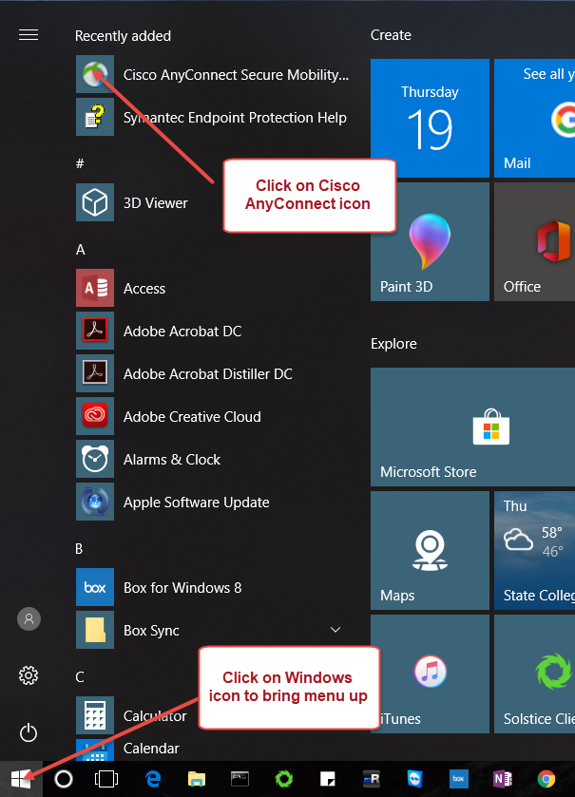
If you don’t need to access the OPP Shared Drives you should use this VPN to connect. This will get you access to Maximo, Docfinity, etc.
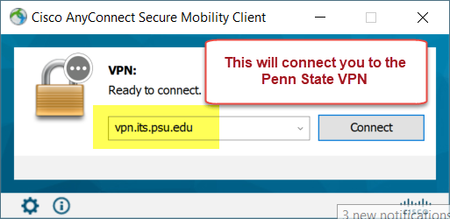
If you need to access the OPP Shared Drives (Vol1, Vol10, etc) you should use this VPN to connect. You can also use the OPP VPN which should be installed on all laptops.
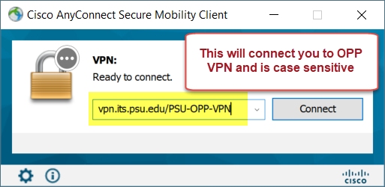

Once you connect to the Cisco AnyConnect VPN you will be asked to login and this will be your Penn State Access account credentials. The Cisco AnyConnect is behind 2FA so you will get a DUO Access request when logging into this VPN.
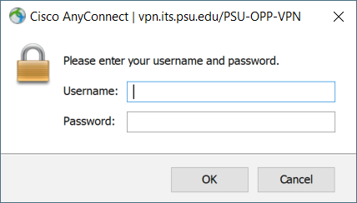
You can also use the OPP VPN if you need to access the OPP Shared Drives. Please try to use the appropriate VPN when connecting as we only have limited connections for OPP VPN and the PSU-OPP-VPN.
If you have any issues using the VPN’s you can reach out to the F&B IT Service Desk for assistance.

