Visual Communications Content Management Guidebook
Office of Physical Plant
Pennsylvania State University

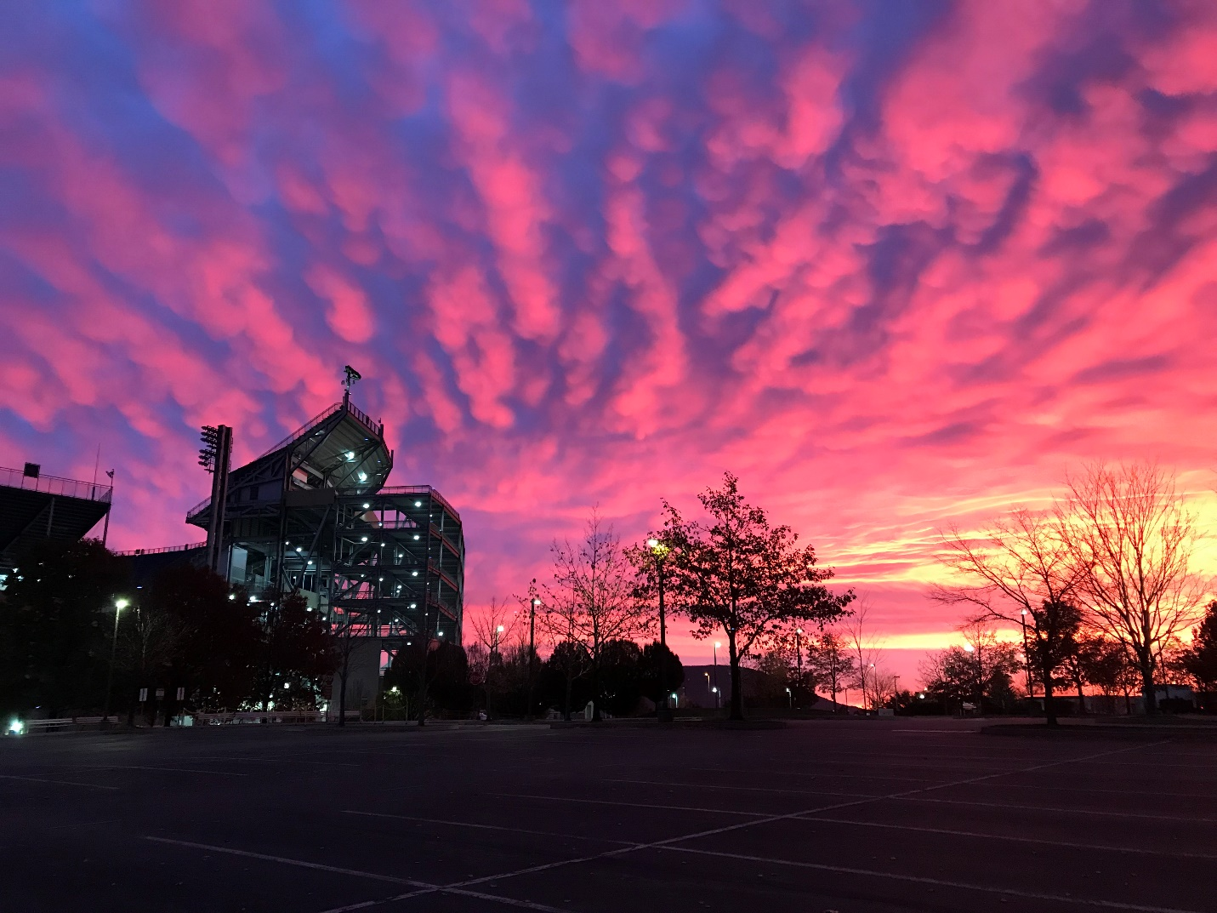

Table of Contents

Digital Strategy............................................................................................................................... 3
Roles & Governance……………………………………………………………………………………………………………….... 6
Displays…………….…………….……………………………………………………………………………………………………….. 7
Communication Categories………………………………………………………………………………………………………. 8
Audiences………………………………………………………………………………………………………………………………... 9
Content Mix……………………………………………………………………………………………………………………………. 10
Display Design………………………………………………………………………………………………………………………… 12

Digital Strategy

Goals
- Provide timely and up-to-date information to OPP employees.
- Reach employees who are both distributed around campus, as well as those who do not or cannot regularly access email.
- Support OPP’s mission of providing quality facility services and safety programs through content.

SWOT Analysis
Strengths | Weaknesses
- Ability to have visual content, not just text  - Allows us to reach employees dispersed around campus through various monitor locations  - Uses program that is user-friendly for those managing content  - Way to provide timely and up-to-date information to employees regardless of whether they’re staff or techs, desk-bound or on the move  - Can tailor content based on location of specific monitors | - Cost? Short term and long term  - Installation – how much time will it take to install, how much will it cost?  - Maintenance – How often will they need routine maintenance? Who will be in charge of maintenance? Cost of maintenance?  - Inability/challenge to monitor effect - How will we solicit feedback from employees on whether or not the signage is useful?  - Potential energy consumption due to monitors being on for extended periods of time – Potential for energy conservation measures that turn off monitors
Opportunities | Threats
- Can reach employees who may not check email regularly, if at all  - May be an opportunity to reach employees who do better with visual communication vs. text  - Numerous places where monitors could be placed  - Ability to tailor messages to the audience a particular monitor serves | - CHANGE – this would be a change for employees and they often resist new ideas and new technology  - Ability to keep content up-to-date and timely. Will more than one person be managing content?  - We are not “selling” anything. Will people pay attention?

Core Messages
- Informative Messages pertaining, but not limited to, the following topics:
  - Human Resources information
  - General Announcements (carpools, new employees, retirees, raffles, etc)
  - Training opportunities
  - OPP events
  - Alerts (road closures, timely warnings, emergency messages)
  - Campus events affecting OPP (weather, sports, community)
  - Initiatives
    - Campus-wide initiatives (All-In, etc)
    - F&B
    - OPP Initiatives (especially important for displays for departmental signs)
  - Meetings (105 A/B, 168D, 202, 214)
  - KPIs, stats, metrics (Propel charts, fun facts/stats, etc)
  - Strategic Goals/Plans
  - Customer Appreciation notes

Cadence of Posting
- Weekly updates with new content going up on Mondays before noon.
  - Messages need to be timely.
    - This requires advance notice and submission of placement requests to content managers for approval by Communications.
    - Submissions must come with proposed dates of posting and removal, and follow a specific format provided to them.
- Content should be removed once out-of-date or 2-3 weeks have passed and the information is no longer timely, relevant, or updated content has been submitted.
- Shared Content Rules
  - Determine what content is shared vs. location/audience-specific

Process for Posting Content
- Approval by area content managers, then…
- Approval by Communications.

Procedure for Monitoring
- Qualitative monitoring via feedback from supervisors signaling increased employee engagement.
  - Are there fewer complaints about a lack of knowledge regarding what’s going on within OPP and at the University?
  - Are there more questions being asked regarding content (training opportunities, events, etc) employees are exposed to via the digital signage?
  - Visitor feedback shared with front desk/reception.

KPIs (must be measurable)
- What is success?
  - Increased employee engagement.
    - Fewer complaints about lack of knowledge.
    - Increased attendance at trainings, events, etc.
    - Positive anecdotal feedback on posted information/
  - Increased customer/visitor engagement.
- Are they effective?
  - One way to measure this is to share registration for an event/training via the digital signage only. Did people register?

Other Notes to Consider
- Sustainability
- Pilot program to gauge effectiveness before full roll out
  - 4 Sign locations to start
- Content Guidelines
  - Design standards
    - How it should look and be formatted
    - Do’s & Don’ts
    - Templates
  - Guidelines for time of display
  - Guidelines for types of content
  - Box folder for content review/approval
  - Submission form indicating type of content, what signs it should display on, etc.

Roles and Governance

Role | Definition | Responsibilities
Content Owners | Content owners generally work in the field of Communications/Marketing. Content owners are well versed in: Brand, value, communication strategy, communications calendar and communications goals. | - Design & standards  - Consistency  - Overall messaging  - Content mix  - Approvals  - Deployment
Content Contributors | Individuals from a particular work unit who share or suggest content deemed appropriate for signage. Content includes new information or updates to existing information. They do not affect the design, but can approve or deny content suggestions to be sent to Content Owners. Information they share is approved by Content Owners. | - Some approvals  - Updates
IT Owners | The IT groups supports the communications by ensuring displays are functioning and playing the content as deployed by Content Owners. The IT group is the network administrator, and grants permissions to users and their appropriate level of access. | - Network admin  - Network connectivity  - Network diagram  - Software updates  - Hardware maintenance  - Oversee new installations
OPP Employees (Staff & Tech Service) | Employees are encouraged to contribute ideas for visual communications. Content can be submitted via email to content contributors or content owners. | - Be engaged  - Communicate with coworkers

Displays

Locations/Zones (Initial Phase)
- OPP Front Lobby
- 148 OPP Break Area
- Outside 105B OPP
- Outside 128 OPP

Display Orientation
A display orientation can be vertical or horizontal. Separate content must be created for each in order to display appropriately.

Size of Displays
Recommended size for all monitors is 55 inches to ensure ability to read screen content.

Communication Categories

Communication Category | Description | Current & New Communication Examples
Need to Know | Communications related to safety, human resources, training, etc. | - HR emails – You@PSU, WorkLion updates, benefits selection  - Safety – Classes, events, tips, etc.  - Training – Classes, registration deadlines, etc.
Alerts | Communications covering traffic, construction, weather, etc. | - Construction – road closures, sidewalk closures, detours, building construction, etc.  - Police & Public Safety notifications  - Emergency alerts (texts)  - Weather - Skyguard
Events | Communications related to OPP-specific events and University events. | - OPP Events – Spring Celebration, Tailgate, Spikes Games, Spirit Days, etc.  - University events – sporting events, town halls, etc.
Community | Communications covering internal events affecting/benefiting the OPP community | - Raffle  - Shoe Truck  - Blood Drives  - Vacation donations
Dashboard | Communications covering specific metrics for OPP giving a snapshot of organizational performance in a variety of areas. | - Safety update  - Buildings & Grounds  - Work Control

Content Submission
Have an event, initiative, program or other communication you would like to share on digital signage? Review directions below.

Directions for Submittal
- Email Susan Bedsworth at sjb5001@psu.edu.
  - Include a rough draft of text. Remember, messaging should be concise.
  - Allow for ample time for Content Owners (see page 6) to review, approve and create content.
  - Include location placement requests (see page 7 for list of monitor locations).
  - Include proposed dates of posting and removal.
- Submitted content should meet guidelines detailed on page 8 of this guide.
- Content will be removed once out of date, information is no longer timely or relevant, or updated content has been submitted.

