Technical Bulletin OPP-TB-26-29-23.100
Variable-Frequency Drives
Motor Insulation Class Requirements

Background

The application of Variable-Frequency Drive (VFD) to existing motors that are driving pumps or fans is a current energy savings measure. We must verify that the motor is capable of being driven by a VFD.

Diagnosis

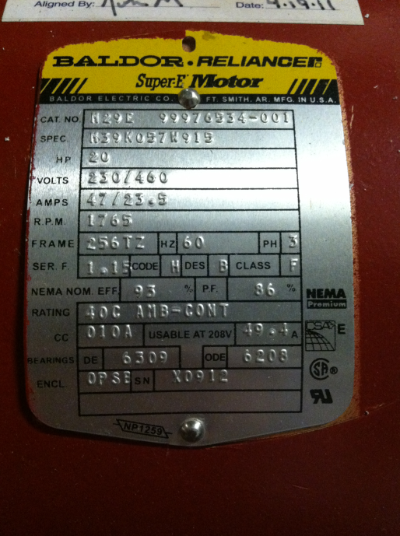
The installation of a VFD on an existing motor may unknowingly cause the motor to fail in a short period of time. The installation of a VFD to control the motor may cause the motor to run hotter. The motor must be checked prior to the installation of the VFD and possibly replaced when the VFD is installed if the motor is not compatible with the VFD.

Corrective Action

The insulation class of the motor is a good indicator of the motors tolerance to increased temperatures. A 10 deg. C (~18 deg. F) temperature rise in the operation of the motor will typically reduce the life expectancy of the motor by half.

Obtain the insulation motor from the motor nameplate class of the data.
Motor insulation Classes are as follows:

A – 221 Deg. F – Not acceptable
B – 248 Deg. F – Not acceptable
F – 311 Deg. F – Acceptable
H – 356 Deg. F – Acceptable
N – 392 Deg. F – Acceptable

The “CLASS” as listed on the motor nameplate data must be class “F” or better to be acceptable for use with a VFD.

Note: Other factors and motor attributes also affect a motors tolerance of being connected to a VFD, however, insulation class and subsequent operating temperatures are a good and quick indicator of a motors ability to be controlled by a VFD. A service factor of 1.15 is also desirable when connecting a motor to a VFD. Also, if you are still unsure of a motors ability to be connected to a VFD, contact the motor manufacturer.

Publisher: Penn State University, Office of Physical Plant, Energy and Engineering Division, Engineering Services
Editor: Raymond H. Alexander – email: rha12@psu.edu
Last Revision: October 10, 2013

