How to register your Token

- Go to 2fa.psu.edu
- Login to WebAccess
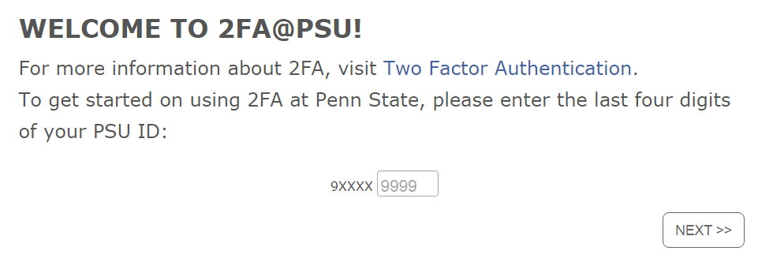
- The next screen:

- Enter your last 4 digits of your PSU ID
- Select Next
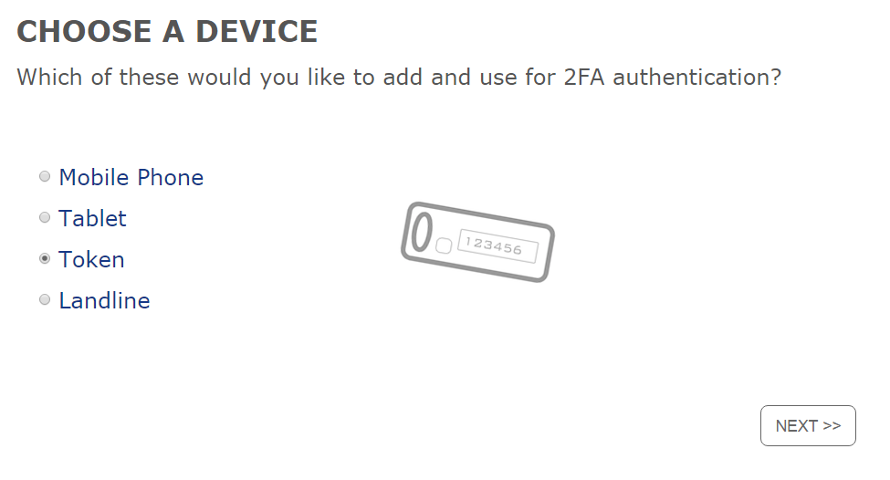
- The next screen is:

- Select Token
- Select Next
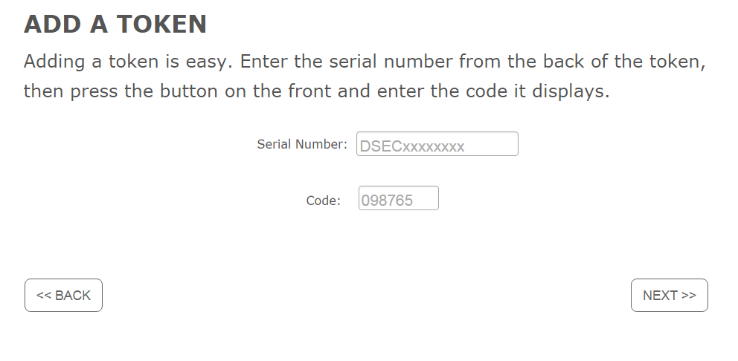
- The next screen is:
- Enter the Serial Number on the back of the token device
- Hold the hard token with the white button on the left side.
- Click on the white button and enter in the internet window the code that populates on the token.
- Select Next
- The next screen is:
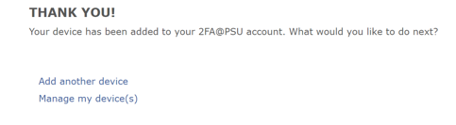
- Select ‘Manage my device(s)’ to see the list of registered devices with 2FA.

Confirm your device using the QA site
- To test the token, go to https://cosign.aittest.psu.edu/
- Log In to WebAccess with your credentials
- On the 2FA site, select the Serial # of your token ID in the drop down list
- Press the white button and enter the code displayed into the website
- Press Log In
- The next screen is:
