Technical Bulletin OPP-TB-255500.002
Chilled Beam Condensation
Sensors

Background

This document is intended to describe the intended purpose of the condensation sensors installed on the bare copper supply piping serving some of the chilled beams in Moore Building and CEDAR Building at the UP Campus or potentially elsewhere within the PSU system, and to recommend actions that an HVAC technician should take when responding to an alarm generated by one of these devices.

Description

A chilled beam is the terminal zone cooling device shown below:

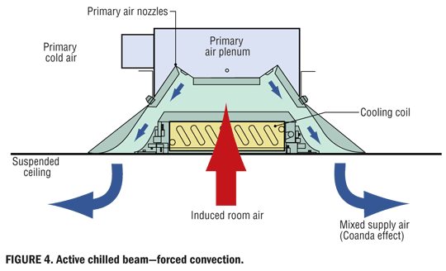

The chilled beams at UP campus are designed to operate so that the cooling coil never actually gets cold enough to allow water vapor to condense on the cooling coil. This is accomplished by supplying relatively warm chilled water to the chilled beam. Instead of the 43° chilled water that normally gets supplied to a fan coil or an air handling unit’s cooling coil, 60° chilled water is supplied to the chilled beam. This ensures that the surface temperature of the cooling coil inside of the chilled beam should never drop below the dewpoint temperature of the induced room air and condense on the coil. If condensation were to occur, it would have nowhere to go, as there is no drain pan or condensate drain. The condensation would simply drip into the occupied space, onto the occupants, their furniture, desk, carpeting, etc.

A control system malfunction that results in a depressed supply chilled water temperature is the biggest threat that chilled beams face from a condensation perspective. The Automated Logic building automation system has some safeguards built into the logic, but the last line of defense against condensation is a special condensation sensor strapped directly to the bare copper entering supply chilled water pipe serving the chilled beam. Upon activation, this sensor will initiate the BAS to close off the campus chilled water supply to the mixing valve that regulates the temperature of the chilled water loop dedicated to serving only the chilled beams. This has the effect of shutting down cooling to those portions of the building cooled by chilled beams. The following is a picture of a pipe condensation sensor.

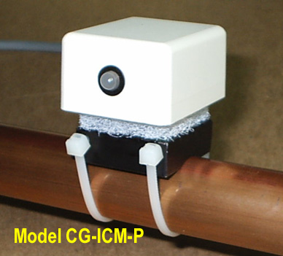

Technician response to a sensor in alarm

If a condensation sensor activates, the following actions should be taken.

- Within the BAS, identify the sensor that has gone into alarm. This may require the assistance of a controls analyst.

- Locate the sensor in the building and check the pipe. Is it wet with condensation? Has the system responded to the sensor alarm by increasing the loop water temperature? Check the temperature of the pipe with an infrared thermometer. If the pipe temperature is below 60°, then there is something wrong with the operation of the mixing valve in the secondary water loop serving the chilled beams. If this is the case, then find mixing valve and manually shut off the campus side chilled water supply to the valve.

- Resist any suggestion to “jumper out” or bypass the condensation sensor circuit just to get the building’s cooling back on-line. The sensor may have been functioning properly, as they are capable of detecting very low levels of condensation.
- Immediately contact the Building Operations Engineer to help establish the next step.
Please provide feedback if you have suggestions for improving or correcting the content of this document. Contact Harry Gebhardt at 814-856-1048.
Publisher: Penn State University, Office of Physical Plant, Energy and Engineering Division, Engineering Services. Editor: Harry Gebhardt, Ph: (814) 865-1048, email: hwg101@psu.edu.

