Official OPP Pollution Prevention/Good Housekeeping Program (PPGHP)
Latest Revision/Review: 5/31/2016

Purpose

The Pennsylvania State University is working jointly with the Pennsylvania Department of Environmental Protection (PADEP) to reduce the quantity of stormwater and increase the quality of stormwater runoff. Parts of University Park are located within US Environmental Protection Agency (EPA) designated urbanized areas; and therefore the University is required to have a Small Municipal Separate Storm Sewer System (MS4) permit, which includes the development of a stormwater management program. The University Park Permit Number is PAI134807. Part of this program includes that each MS4 permittee develop a Pollution Prevention/Good Housekeeping plan. What follows is the plan for University Park.

Types of University Facilities

The Pennsylvania State University owns and maintains approximately 16,000 acres of land in the Centre and Huntingdon Counties, Pennsylvania area around its University Park Campus. However, the Environmental Protection Agencies 2000 Urban Area Map only includes approximately 1,120 acres of land under the MS4 Permit. Nonetheless, from a pollution prevention and good housekeeping perspective, the University treats these issues the same in all areas.

The University within most of the campus area owns:

- Roads and driveways, not including municipal or State roads,
- Buildings including residence halls, administrative, labs, venues, etc.,
- Parking lots including temporary grass parking areas,
- Open space including lawns, athletic fields, agricultural areas, etc.
- Fleet operation areas including fuel stations,
- Landscape maintenance shops,
- Athletic maintenance shops,
- Recycling and composting centers,
- Chemical storage areas,
- Wastewater treatment and other utility plants,
- Utilities distribution including gas, steam, chilled water, electric, telecom, sewer, water,
- Stormwater facilities including conveyance and BMPs,
- Regulated dams, and
- Active construction areas.

Types of University Operations

- Pesticide and Herbicide use for research and operations,
- Landscape operations including fertilizers,
- Street sweeping,
- Snow removal and deicing,
- Utility construction, maintenance, and repair,
- Food and waste recycling,
- Vegetation composting,
- Vehicle fueling,
- Vehicle washing and maintenance,
- Chemical handling, including lab waste and chlorine storage.

Related Programs

The University has developed policies and programs related to pollution prevention and good housekeeping. These are:

1) Stormwater Facilities Inspection Policy,
2) Illicit Discharge, Detection and Elimination Program,
3) Construction Site Stormwater Runoff Control Standards,
4) Post Construction Stormwater Management Requirements.

Training Areas of Responsibility

The Office of Physical Plant’s Engineering Services group is responsible for the overall pollution prevention and good housekeeping policy of the University. However, because of the size of the University, the number of employees, and the scope of activities at the University, different people have direct day to day responsibility for specific areas including training activities for responsible staff. These are:

- Buildings and Grounds:
- Landscape Maintenance – Supervisors, Grounds Maintenance
- Snow Removal and Deicing – Supervisors, Grounds Maintenance
- OPP Fueling/Garage – Supervisor Garage Services
- Composting – Supervisor, Recycling and Refuse Services
- Recycling – Program Manager, Solid Waste Operations
- Auxiliary and Business Services:
- Housing – Director, Housing Services
- Food Services – Various Food Service Directors
- Hospitality Services – General Manager, Hospitality Services
- Bryce Jordan Center – General Manager, Bryce Jordan Center
- Transportation Services:
- Fleet – Fleet Services Manager
- Parking – Parking Manager
- Airport – Director, University Park Airport
- Utility Systems – Supervisor of Utility
- Stormwater systems – Wastewater Supervisor of Utility Services
- Wastwater treatment Plant – Wastewater Supervisor of Utility Services
- Power Plants - Superintendent Steam Services
- Utility line brakes – Supervisor Construction Services
- Chemical Storage and Disposal – Hazardous Materials Program Manager, Environmental Health & Safety
- Spill Prevention and Cleanup – Manager, Environmental Health & Safety
- New Construction Activities – Director, Design and Construction
- Erosion and Sediment Control – Permit Engineer, Engineering Services
- Athletic Facilities Maintenance – Athletic Field Supervisor
- Agricultural Fields – DAS, Coordinator of Support Units
- Farm Operations – Manager Farm Services
- Research Facilities – varies

Training

Engineering Services shall meet with the Utility Services staff at least quarterly and report changes and/or updates in MS4 policies and program requirements to the supervisors. Engineering Services will meet with other groups on an annual basis. Additional training is available upon request.

Engineering Services has also developed general training aids to be located on the OPP stormwater website:

http://www.opp.psu.edu/services/stormwater/training-and-education

Sources of Additional Training Materials

EPA Municipal Training and Education Website:

http://cfpub.epa.gov/npdes/stormwater/menuofbmps/index.cfm?action=factsheet_results&view=specific&bmp=129

EPA Pollution Prevention/Good Housekeeping for Municipal Operations Website:

http://cfpub.epa.gov/npdes/stormwater/menuofbmps/index.cfm?action=min_measure&min_measure_id=6

The Alameda Countywide Clean Water Program has developed a number of pollution prevention brochures at:

http://www.cityofalamedaca.gov/Go-Green/Clean-Water-Resources

Training Requirements

The University has numerous good practices instituted across the campus; however, besides direct training for stormwater issues, these practices have not been compiled/documented as part of the original 2003 permit. This will change starting with the new MS4 permit in 2013.

Additionally, the 2013 permit modifications may potentially require employee training to occur at least annually (during each permit coverage year) and shall be fully documented in writing and reported in the annual reports. Documentation shall include the dates of the training, the names of attendees, the topics covered, and the training presenters. The identified area of responsibility personnel will need to provide this information to Engineering Services.

The University developed a training plan (separate document) and has been implementing the plan.

Pollutants of Concern

The tables on the following page provide lists of general facilities and activities, and what potential pollutants may be associated with them.
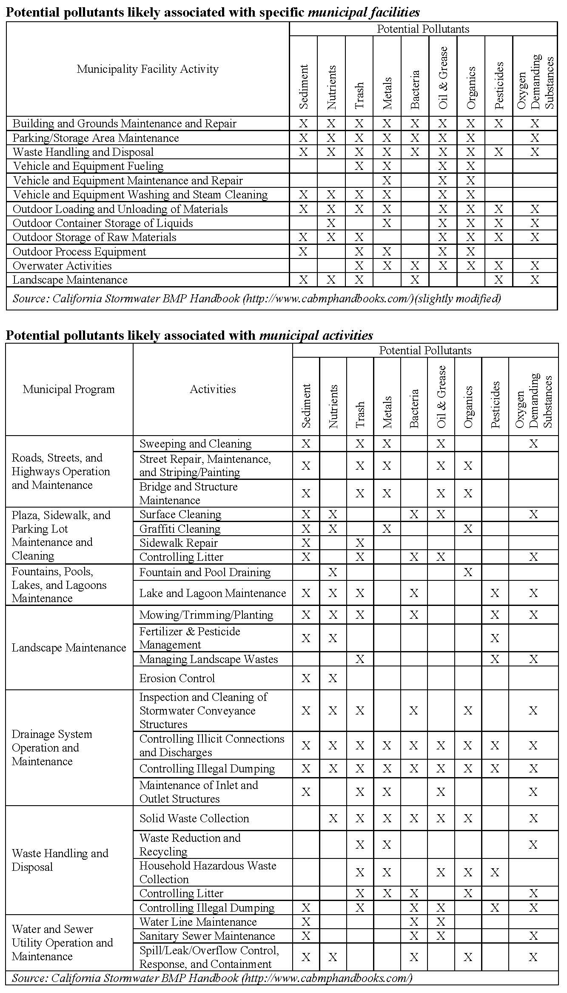
Source from EPA: http://epa.gov/npdes/pubs/potmunpoll.pdf

