How to register your University-reimbursed smart phone
- Go to 2fa.psu.edu
- Login to WebAccess
- The next screen is:
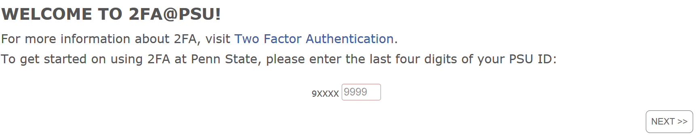
- Enter your last 4 digits of your PSU ID
- Select Next
- The next screen is:
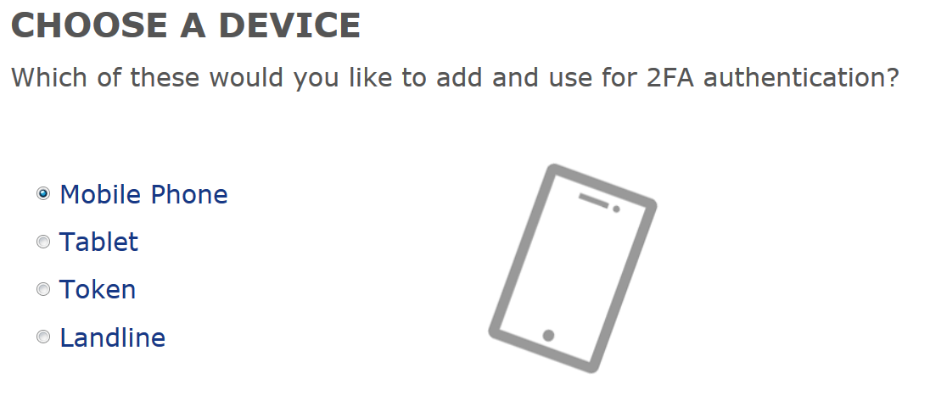
- Select Mobile Phone
- Select Next
- The next screen is :
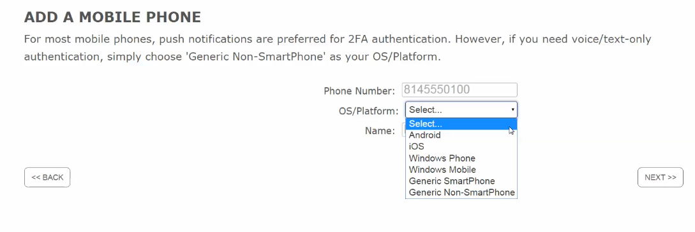
- Enter your Cell phone #
- Select the OS/Platform (e.g. iOS, Android, Generic Non-Smart Phone, etc)
- Enter a name for your device (for you to recognize)
- Select Next
- The next screen is:
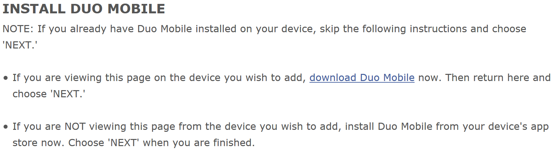
- IF YOU HAVE NOT DOWNLOADED THE DUO MOBILE APPLICATION ON YOUR SMART PHONE, YOU NEED TO DO SO NOW. FOLLOW THE DIRECTIONS BELOW:
  - In your SmartPhone, go to either the AppStore, GooglePlay, etc
  - Search for ‘Duo Mobile’
  - You will see the following app:
  - Install/download the app on your phone; you will need to enter your Apple ID or Google Play ID to install it.
  - Open the Duo app once it’s installed.
  - Click OK to allow for Dup Mobile to send you notifications
  - Click Accept for the Agreement clause
  - Set your cell phone down
- Click Next on the 2fa.psu.edu screen (displayed above #13 above)
- The next screen is:
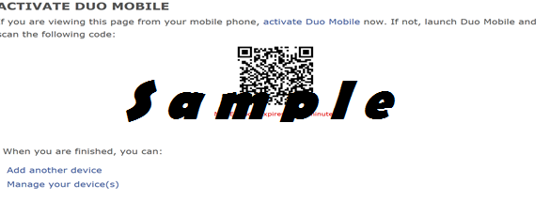
- Pick up your cell and Click ‘Add Account’ on your cell phone in the Duo Mobile app
- Select OK in the duo mobile app to allow it to access your camera
- Hold your phone camera to your computer screen to scan and activate the code shown on the screen.
- Congratulations! Your SmartPhone is now registered with 2FA.

Confirm your device using the QA site
- Go to: https://cosign.aittest.psu.edu/ (the thumbprint will have QA on it; it’s not production)
- Enter your WebAccess login
- Select Log In
- The next screen is:
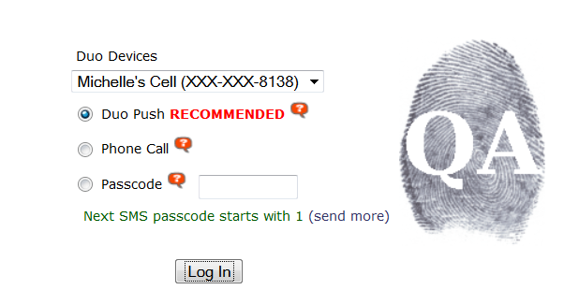
- Keep the defaulted information selected (Duo Device = your mobile name and Duo Push)
- Select Log In
- Your mobile will alarm you that a Duo mobile request has been triggered
- The bottom of your mobile screen will look like this on your mobile
- Select Approve on your mobile screen within the Duo app.
- The Duo app will show Approved!
- If you look on the computer screen, it will now show this from the QA site (which represents you logged in successfully to WebAccess and 2FA):
When 2FA is turned on by the University, this screen will represent whichever system you are logging in to (e.g. ESSIC, timecard, etc).
