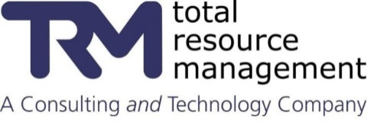

Maintenance Period Bundling
Penn State University
Task 4.8 – Develop Work Bundling Process

Task Number: | Task 4.8 | Version: | FINAL DRAFT
Creation Date: | 07 August 2017 | Source: | TRM
Author(s): | John Reeve | Owner: | John Reeve
Delivery Updates
John Reeve | 8/24/2017 | Incorporate TRM internal review comments
John Reeve | 8/24/2017 | Send to PSU Leadership
John Reeve | 9/5/2017 | Incorporated PSU leadership team comments

Table of Contents
Executive Summary 5
1. Introduction/Background 6
Overview 6
Workshop attendees 6
Work management with Bundling Concept 6
Definitions 7
2. Problem Statements 9
Lack of Formalized Maintenance Period Planning 9
Major Maintenance Codes are inconsistent 9
Defect tracking is not a recognized strategy 10
Lack of Work Order Link to future Maintenance Period 11
The CMMS Work Order screen design is not ideal for failure mode capture 11
3. Nine-Point Program for Building Surges 13
Program Objectives 13
Goals 13
Assumptions 13
High Level Process Flow 14
3.1 Defect Tracking - the Concept 14
Defect Entry Screen Purpose and Function 15
Understanding Defect Sources 16
Three Types of Work 16
Defect Policy 16
Defect Elimination as an Improvement Initiative 17
3.2 Universal Failure Coding Design 17
Actionable Failure Data 17
Create failure coding that works for both assets and locations 18
Using a 3-Part Failure Class as Level-1 18
Use Failure Class 3rd Element to drive Failed Component Values 19
Other Combinations 20
Use a Generic Code Set for Problem Codes 21
Below is a set of standard problem codes: 21
Setup the Component Problem Code 22
Setup a Cause Code Hierarchy 22
Failure Analysis 23
Cause-4: Eliminating the real Defect 23
Setup Remedy Codes 24
3.3 Link work to Building Surge 24
Coding the Backlog 24
Work Order Categorization and Reporting Requirements 24
3.4 Establish Building Selection Criteria 25
Selection criteria provides transparency 25
Technique to capture Average Annual Maintenance Cost 25
Technique to capture Estimated Backlog Hours 26
3.5 Countdown Schedule 27
Single Building Countdown 27
Multiple Building Countdown 27
3.6 A Walkdown Checklist 28
Mobile device 28
Grading Condition 28
Generic Checklist Example 28
Utilize Failed Component List to drive Building Walkdown Checklist 30
Validate Installed Equipment (identified in Maximo) 31
3.7 Build a Detailed Schedule 32
Schedule Activities should have Calendar attribute 32
Progressing Reporting should be flexible 32
Schedule Fundamentals 32
3.8 Stage Materials for Repair and Construction 33
3.9 Customer Satisfaction 33
PR Campaign 33
Conduct a Lessons Learned Review 34
4. The Benefits of work bundling 35
4. Process and Roles 36
4.1 Process Flow – with Statuses 36
4.2 Roles and Responsibilities - Suggested 36
5. Discussion on Possible System Configuration 38
Work Reception Entry Screen 38
New Defect Tracking – Field Requirements 38
Failed Component and Component Problem Relationship 38
Automatic Rough Estimate 38
6. Go-forward Action Plan 40
List of Significant Tables/Figures
Figure 1 –Nine Point Program for Building Surge 5
Figure 2 –Work Management with Bundling Concept 6
Figure 3 – Major Maintenance Codes with WO counts 10
Figure 4 –The Impact of Defects 11
Figure 5 –Current WOTRACK entry screen 12
Figure 6 –Nine Point Program in Process Order 14
Figure 7 –An entry screen to track defects 15
Figure 8 –Five Primary Sources of Defects 16
Figure 9 –Three Types of New Work 16
Figure 10 –Defect at Millennium Building 16
Figure 11 – Significant fields used with chronic failure analysis 17
Figure 12 – Actionable Failure Data 18
Figure 13 – Note the use of “COMPONENT” in third segment of Failure class 18
Figure 14 –Explaining Universal Failure Codes 19
Figure 15 –Misc. Component-Problem Combinations 21
Figure 16 – Generic Problem Code List 22
Figure 17 –Cause Code Hierarchy 23
Figure 18 –Identifying Systemic Cause 23
Figure 19 –Remedy Codes 24
Figure 20 – Building Selection Criteria Formula 25
Figure 21 –Calculation example for Avg Annual Maint Cost / Replacement Cost 26
Figure 22 –Calculation example for Estimated Backlog Hours 26
Figure 23 –Single Building Countdown 27
Figure 24 –Overlapping Surge Planning 27
Figure 25 –Mobile device with carry strap 28
Figure 26 –Condition Grading Example 28
Figure 27 –Checklist references common failure modes 30
Figure 28 – Validating equipment tags 31
Figure 29 –Activities in Schedule with different Shift-Calendars 32
Figure 30 –Various options of progress reporting 32
Figure 31 –Pictures of possible staging locations 33
Figure 32 – One-off jobs versus Work Bundling 35
Figure 33 –Process Flow with Status Changes 36
Figure 34 –Nine Point Program in Process Order 38

Executive Summary
Facility maintenance can be quite challenging when dealing with hundreds of buildings. It is absolutely critical that the trades be the eyes and ears through PM inspections, defect discovery and facility coordinator conversations as there are many factors which determine the need for building maintenance (scheduled and emergent). That said, some buildings require annual shutdowns which are carefully scoped, resourced and scheduled in advance. These annual shutdowns, called maintenance periods, last 4 to 5 days.
Some buildings are harder to gain access to than others due to in-use requirements. Physical plant maintenance however needs to perform scheduled corrective maintenance as well as preventive on a regular basis. By bundling work together to form a focused work event, it is possible to do more work in a shorter period of time with overall less impact to the customer.
This document will describe the entire process of work bundling including defect tracking, scope control, universal failure codes, building selection criteria, countdown schedule, walkdown checklist, materials staging, a detailed work schedule, and customer satisfaction.
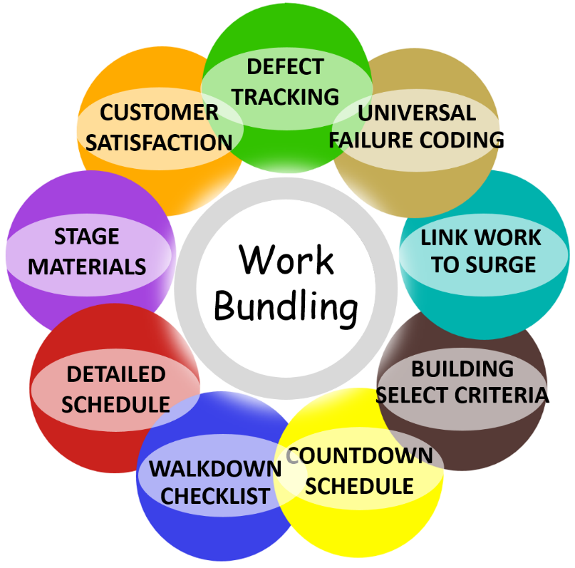
Figure 1 –Nine Point Program for Building Surge

John Reeve
Sr. Business Consultant, CRL
Total Resource Management

Introduction/Background

Overview
The consultant conducted on-site interviews during the periods of 19 June, 10 July and 24 July. The purpose of this scope is to fully identify the process of building surges and greatly expand upon current design. The current process is mostly informal. There is usually someone in charge of the maintenance period but the “schedule” is informal and may be just a list of work. The customer, academia, is notified in advance that there will be a maintenance period beginning on a specific date, and the entire building will be affected.

Workshop attendees
The following staff members offered guidance in this improvement initiative.
Ian Salada | Director Work Control
Peggy Shaner | Manager Planning and Scheduling
Bill Steudler | Maximo application design engineer
Joseph Lonjin | Business Analyst
Mike Snider | Manager Maintenance Programs
Jordan Good | Planner

Work management with Bundling Concept
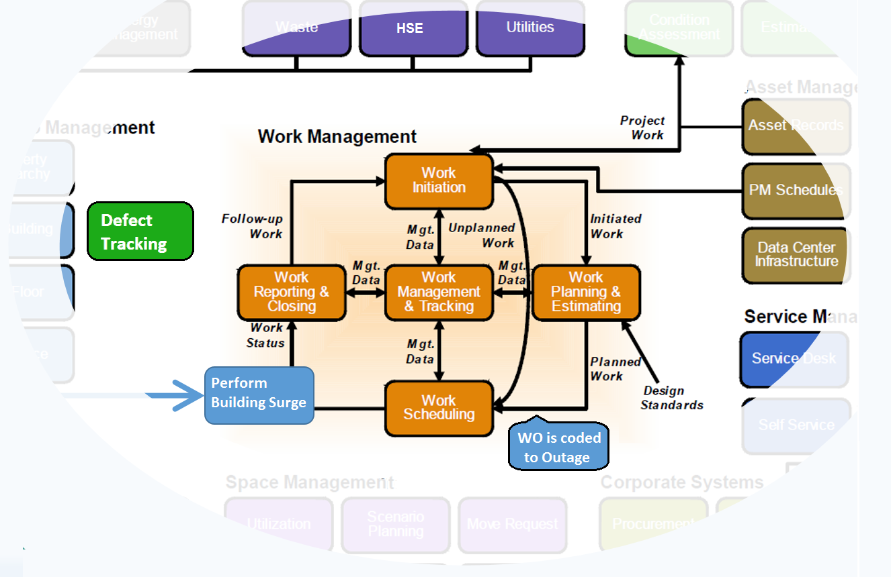
Figure 2 –Work Management with Bundling Concept

Definitions
Maintenance period | The maintenance period is a phrase generally meant to specify a 4-5 day focused event which has work performed under one shutdown request. It is a scheduled shutdown of one or more buildings – or a portion of a building. A meaningful maintenance metric might be to compare pre-outage size of the backlog including all non-PM work versus post-outage size.
Work bundling | This is more of a concept or philosophy where the grouping of work common to an area facilitates work optimization through combined resources (craft and materials). Materials for example can be ordered in advance and staged near the building to minimize windshield time.
Building surge | Some buildings require special attention by Physical Plant Maintenance based on selection criteria. Once the building is selected, a “surge” can be performed against that building to accomplish multiple jobs at the same time.
Building Surge Manager | This role is responsible for work scope selection, scope freeze, staged materials, schedule generation, and customer notification. This role would work closely with Physical Plant Maintenance leadership team to determine the next set of buildings.
Detailed work schedule | The term schedule could mean a list of activities stored in M/S Word. However, in this proposed solution, a detailed work schedule would be created/stored inside a formal scheduling software program and resource leveled.
Defect | A defect is… “Anything that erodes value, reduces production, compromises EHS or creates waste" [per Winston Ledet].
Defect Elimination | Defect elimination is strategy focused on identifying and removing defects. It relies on small, cross-functional action teams which strive to eliminate the defect forever. Their goal is to make it better, i.e. “Don’t just fix it, Improve it.” which is also TPM.
Defect Tracking | Defect tracking should be accomplished using an application within Maximo. It is intended to be different from a work order record in that it may be very minor in nature or it could be work which has been deferred but needs to be tracked.
Failure Class fields | The proposed design for the “new” Failure Class value is a 3-part field.  Examples are: BLDG-ROOM-DOOR, and BLDG-ROOM-????  The Failure Class originates on the asset or location and crosses over to the work order Failure Class. Note: asset.failurecode is dominant.
Universal Failure Coding | This is a technique to capture failure mode by failure class. It uses the asset and location record failure class field (workorder.failuecode) to store a 3-part code set whereby the 3rd element drives the failed component list. [see Type of Work]
Asset condition | Asset condition is a measure of asset health. Asset condition is a subjective grading technique which stores a numerical value as chronological history. When thousands of assets are involved, it is helpful to have an overall awareness of plant condition. This assessment can be performed in parallel with a scheduled preventive maintenance (PM) task. By capturing asset condition you can trend values and make proactive decisions.
Deferred Maintenance | Deferred maintenance is the postponement of building and equipment upkeep from a budget cycle due to a lack of funds. This lack of funding can cause eventual neglect and worsening of conditions.
Capital Renewal | Capital renewal is the planned replacement of building subsystems such as roofs, electrical systems, HVAC systems and plumbing systems that have reached the end of their useful life
Type of Work  Table | The Type of Work repository is defined as the combination of Failure Class 3rd element, failed component, and problem code. An example of this:  DOOR || LATCH || FUNCTION  This repository would also have the  LEADCRAFT || SKILL  And for the above combination there would be an HOURLY RATE.  This repository could be a new domain, an existing application (such as craft), or a new application altogether.
Defect Rough $ Estimate | The Hourly Rate is then extracted from the Type of Work table and multiplied times the DURATION to get a Rough $ Estimate.  This must be an automatic calculation.

Problem Statements

Lack of Formalized Maintenance Period Planning
At present there is an informal process and handful of selected buildings that have annual maintenance periods. This is a missed opportunity in terms of enhancing work force productivity, efficient backlog reduction and customer satisfaction. If we agree that “work bundling” as a concept is a good practice it may be worthwhile to formalize this process. By formalization we mean establishing a procedure with clear roles and responsibilities relating to building surge activities. Topics would include how buildings are selected, how the work is scheduled, and how a walkdown should be performed. The goal with this entire effort is to improve overall facility condition through effective use of resources.

Major Maintenance Codes are inconsistent
Major maintenance codes are used on all work orders. But the significance here is that they are involved with work categorization for facility management reporting. Unfortunately the following list of codes has a mishmash of entries where some categories are at the system level, some are locations/assets, some are components, and some are just too general. In addition, some categories are not mutually exclusive or have the appearance of being unclear, which confuses the working level and leads to poor coding, and thus, inaccurate reporting.
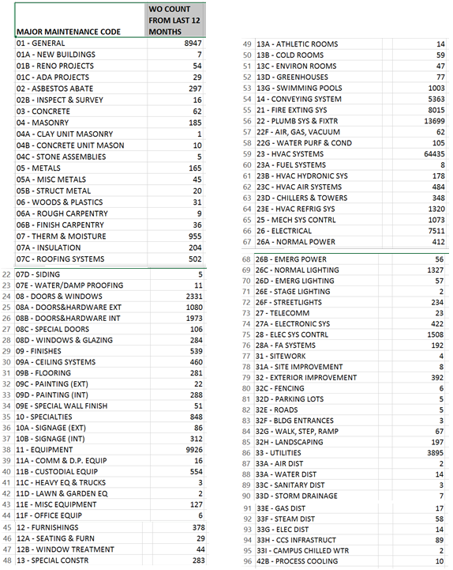
Figure 3 – Major Maintenance Codes with WO counts

Defect tracking is not a recognized strategy
There may have been some prior directives to “capture all defects” but the repository may be inadequate for formal cost tracking. All indications point to a mostly undocumented process to capture defects. If they are captured (Log notes) this data is inadequate to perform value-add analysis.
There are several ways for defects to originate per figure below, and in order to reach the precision maintenance domain, these must be discovered and eliminated.
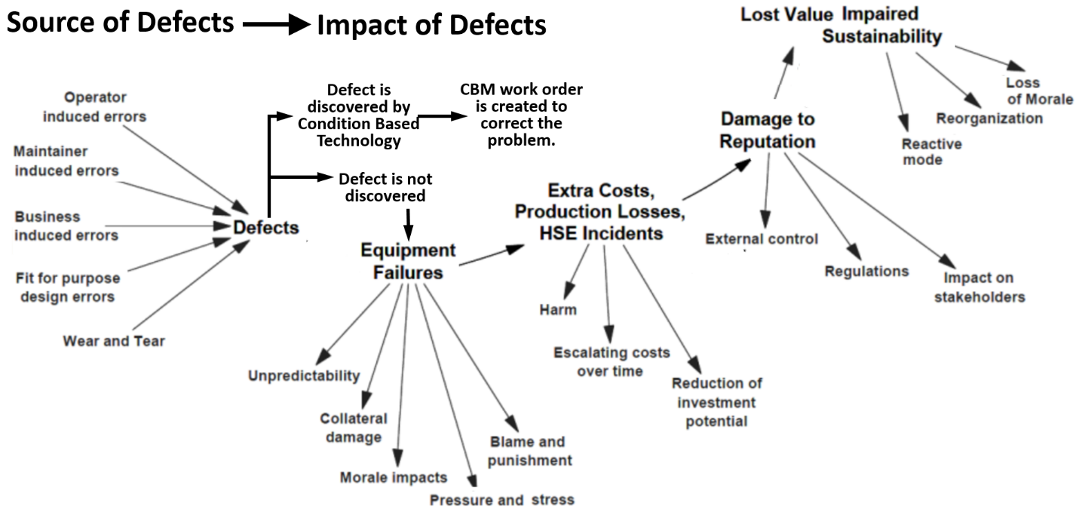
Figure 4 –The Impact of Defects

Lack of Work Order Link to future Maintenance Period
When building a new maintenance period schedule, the Building Surge Manager should heavily rely on the existing maintenance backlog. This work needs to be verified accurate. With that understanding, there does not seem to be a field on the work order to link a job to a future maintenance period. This would be important because, once linked, you wouldn’t want someone to do this work before that scheduled event. And this helps to provide scope control. Below are example work order fields:
Field #1 | (Y/N) Perform this work in next scheduled building maintenance period.
Field #2 | This scope approved by [PERSONID]
As an alternative to the above design, you could utilize WPCOND status with subcodes similar to BACKLOG functionality.
Some buildings will always have annual maintenance periods. And some buildings will never be considered for a maintenance period. There is a “middle grouping” which will be selected based upon selection variables. Building location records need a new field which defines the applicability to maintenance periods:
Field #3 | This field would have a domain: (1) EVERY YEAR, (2) CONSIDERED, (3) NEVER
The “considered’ value means this building would be considered depending on the calculated formula.

The CMMS Work Order screen design is not ideal for failure mode capture
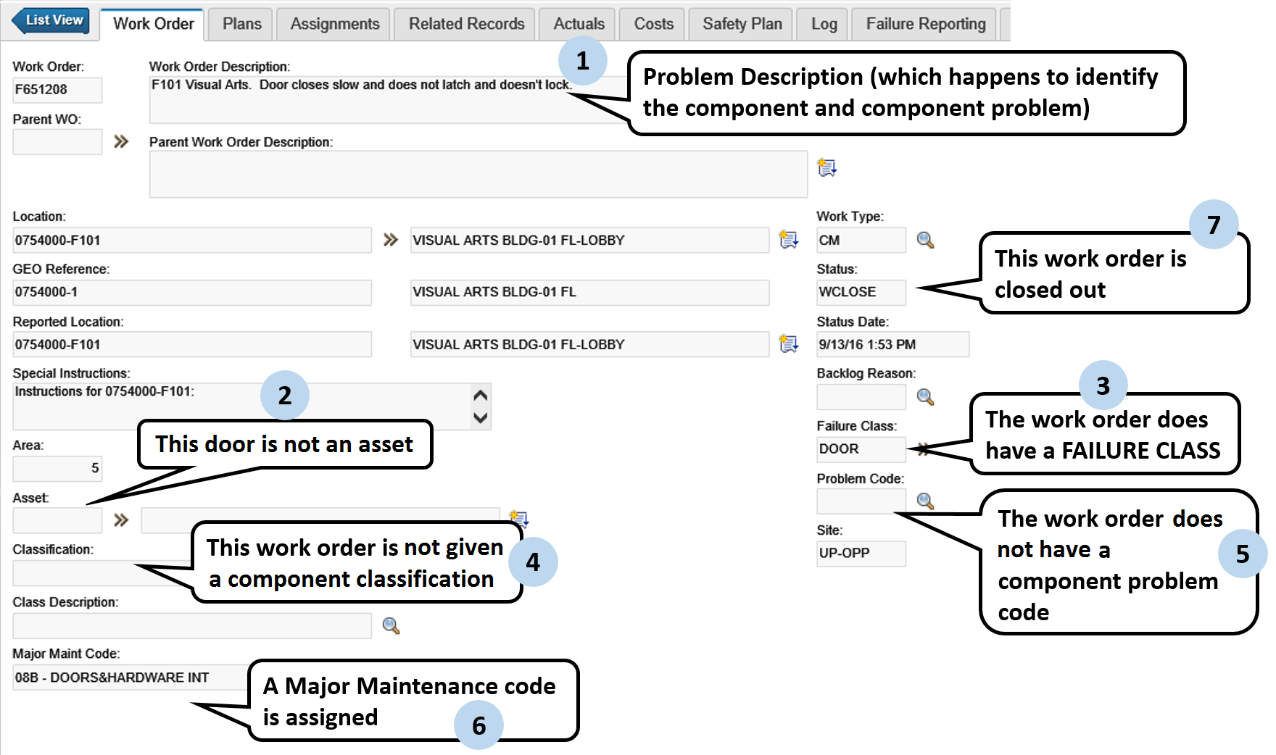
Figure 5 –Current WOTRACK entry screen
- The work order description is well worded and defines the problem but it is not possible to perform aggregate commands using actionable data fields for failure analysis.
- Some doors are assets and some doors are not. This is okay - but we will need a ways to get consistent failed component data.
- The failure class is okay in this use.
- The classification field is not used.
- The asset problem code is blank (for a closed work order).
- The major maintenance code is too general (does not identify failed component which is Latch). There could also be a problem with the closure arm.

As to the Problem Code set, there is confusion as to whether this is for components or “problem codes”.
Example: DOORS  This existing problem code list is a (1) mixture of problems and components, (2) contains the word “OTHER”, and, (3) contains values which are similar, i.e. BROKE and DAMAGED. As a result the working level will be confused and not be consistent in their failure coding. | 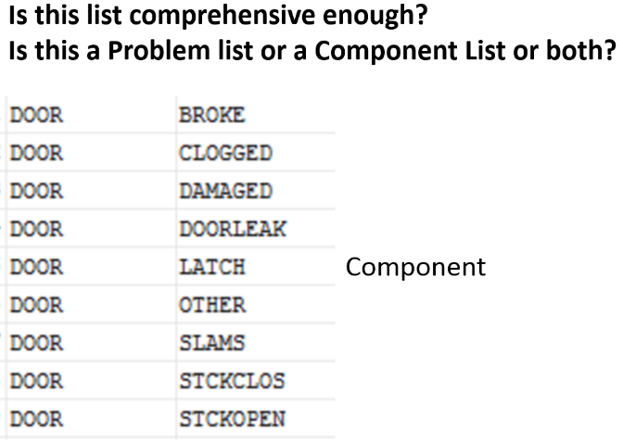

Nine-Point Program for Building Surges

Program Objectives
- Establish comprehensive program for building surge maintenance with schedule, purpose statement, and cost benefit.
- Identify critical roles and responsibilities
- Focus on the failed component and component problem which supports a RCM design model.
- Implement work scope and schedule control methods
- Identify resource requirements (staff and materials) – including contractor management
- Develop a comprehensive building checklist program. Develop “things to check” list by asset classification or room location
- Improve work categorization design (reference: major maintenance codes)
- Improve list of likely components and component problem codes
- Promote a transparent selection criteria
- Identify-manage risks associated with surge

Goals
- Enhance customer satisfaction
- Maximize work scope and craft efficiencies
- Improve foundation data accuracy (by capturing missing assets)
- Improve Facility Condition

Assumptions
1 | The building surge program will have a Manager in charge plus formal schedule.
2 | The work in the Maximo backlog will be linked to upcoming maintenance periods – as appropriate.
3 | The failure coding on the work order will capture failure mode and have links to upcoming building outage (where appropriate).
4 | Building walk-downs will be performed prior to the maintenance period using a checklist.
5 | A selection criteria will be used to select buildings.

High Level Process Flow
On the surface, this project scope seemed to be cut and dry: Create a Work Bundling Program. But as the workshops progressed it appeared there were many opportunities to improve process and add efficiencies. Plus, there were several sub-topics which related to work bundling such as defect tracking, universal failure coding, building selection criteria formula, improvement of the walkdown checklist concept, and, the work schedule. If all 9 points below are to be followed, this will produce a substantial net improvement in customer satisfaction.
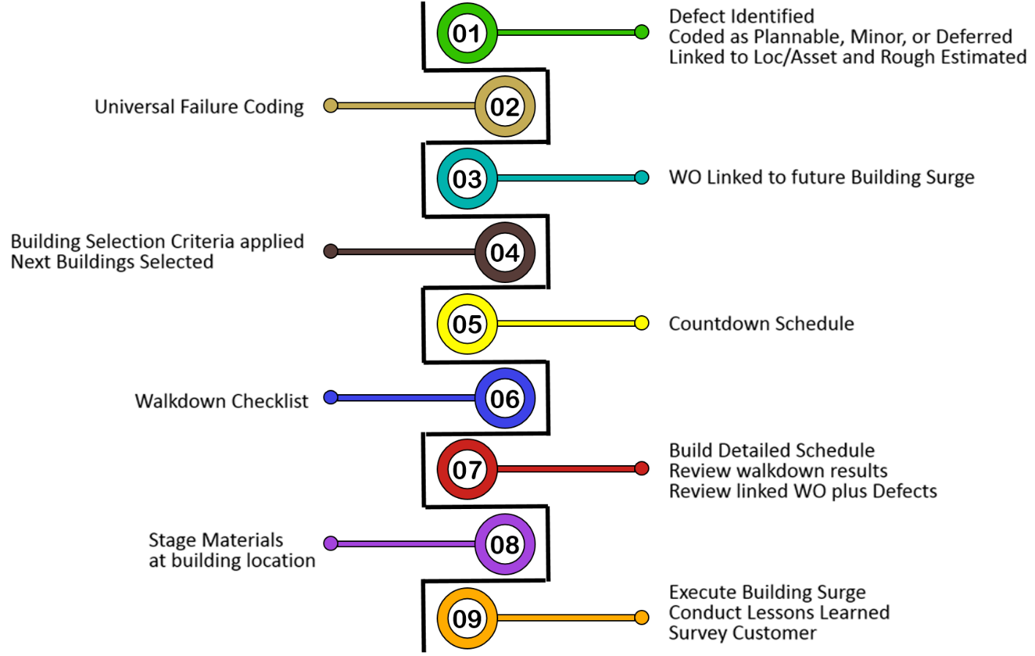
Figure 6 –Nine Point Program in Process Order

Defect Tracking - the Concept
Sometimes there might be a dialog around what is a defect? Or, should we even enter that minor repair into Maximo? The definition of a defect is shown below. But as to whether or not it gets captured in which way, the following considerations should be known:
- Minor defects when discovered should normally be remedied during that visit. However, in some cases, this is not possible due to material requirements or resource availability.
- Minor defects, that were discovered, should be categorized inside the CMMS system. This can be done three ways: in the (new) defect tracking screen as individual entries, or, as part of a blanket work order, or as a new work order.
- In some cases, a defect may be categorized as Deferred Maintenance – inside the Defect Tracking screen.

Defect Entry Screen Purpose and Function
This screen/application would allow the capture of a distinct record called a Defect. All new (repair) work starts out as a defect. The only questions are urgency, magnitude, and is it plannable work or something to be deferred. A defect can be discovered while performing an inspection or other repair work. It could be reported by OPP WCD staff or a facility coordinator.
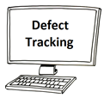
Figure 7 –An entry screen to track defects
By making this a separate record apart from the work order we achieve the following:
- Work reception would still process incoming work like they always do. But if work reception deems this task would be better tracked as a defect record (or deferred maintenance) they would then code accordingly [Note: This flow process has not been thoroughly worked out].
- There is a benefit to keeping defect records separate from work orders, and that is, to not overwhelm the plannable work listings in the open backlog.
- But at the same time, when leadership wants to sweep up ALL open records against a building-location, they can do so, in one source.

Understanding Defect Sources
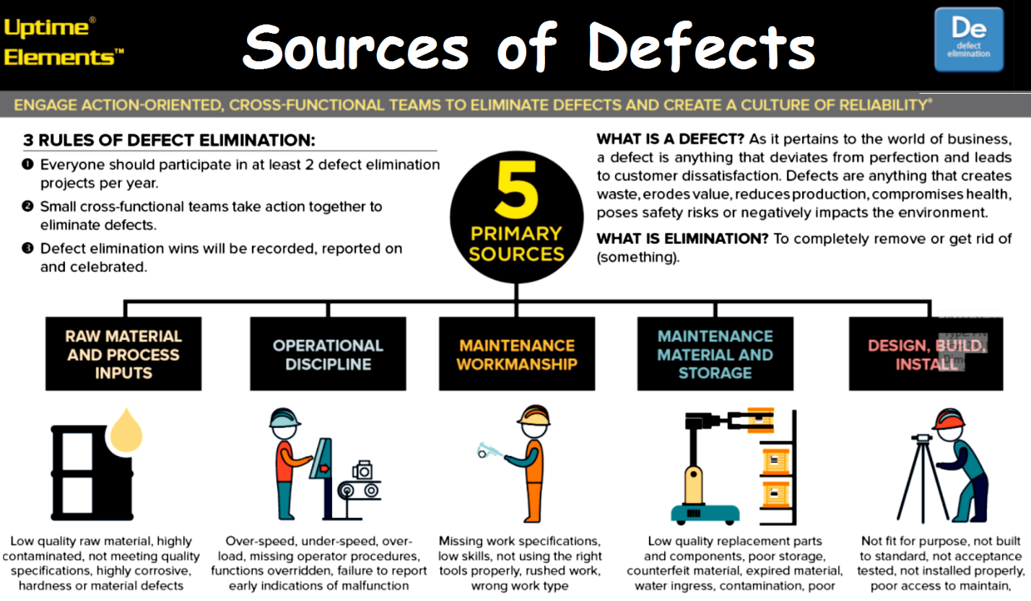
Figure 8 –Five Primary Sources of Defects

Three Types of Work
A defect can be discovered during routine maintenance or inspections. It can also be discovered duing a building surge walkdown.
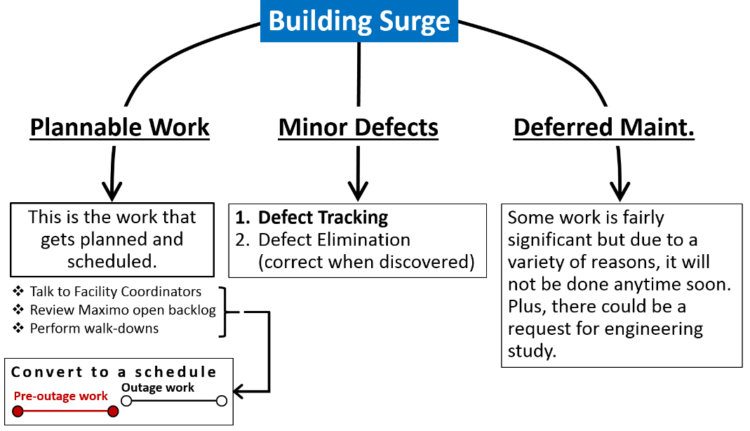  Figure 9 –Three Types of New Work | This is an example of a building defect.  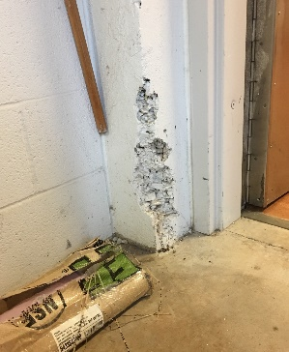  Figure 10 –Defect at Millennium Building

Defect Policy
It is a best practice to capture all known work including minor defects at a site. For some however they don’t want this minor work to clutter up the work order backlog. But if we design a new application we can separately track defects as well as deferred maintenance. This could be an entry screen for all incoming work. The work reception team would process this as a defect which may be converted to a work order (and dispatched or routed to planning). Conversely some defects will be left as is wherein some might be categorized as deferred maintenance.
Note: Defect Tracking and Defect Elimination are related but different concepts.

Defect Elimination as an Improvement Initiative
Defect elimination is a program where a cross-functional team regularly meets to walk-down a specific system and as a group identify issues (potential failure modes). The goal of this team is to not only identify issues but to also fix them on the spot – when possible. Or, they assemble materials/resources to fix within 24 hours. For both of these scenarios the actual man-hours are charged to one blanket work order called DEFECTS-17-08 (which is defect remediation for the month of August). In other instances the identified work will either be (1) placed onto an individual work order, or, (2) categorized as deferred maintenance.

Universal Failure Coding Design
This is a proposed design. The core team may decide to take a different approach.
Good failure coding can help drive the walkdown checklist design.

Actionable Failure Data
In addition to the above background, most CMMS products do not normally accommodate for a true failure mode design – which is the language of RCM. Historically, the CMMS main emphasis is at the asset level. While the asset taxonomy is important, a meaningful failure analysis process needs actionable data at the component level.
Note: With careful thought, the CMMS product can be configured using basic alteration tools.
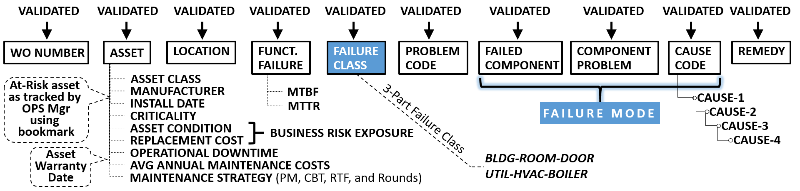
Figure 11 – Significant fields used with chronic failure analysis
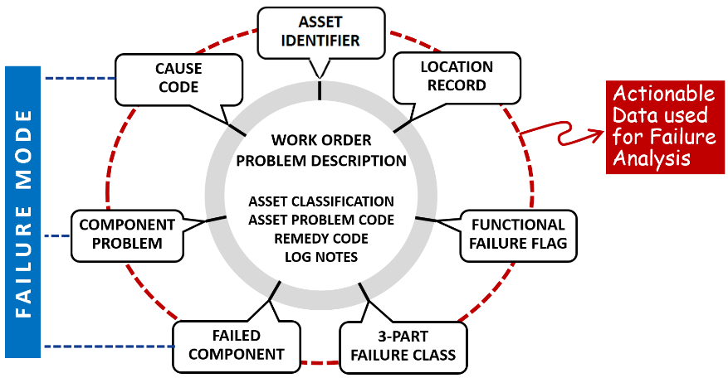
Figure 12 – Actionable Failure Data

Create failure coding that works for both assets and locations
Using the building-room doors as an example, some are true assets and some are not. The latter example is only identified as a location record with the lowest hierarchical element is the room itself. The goal is to capture all problems with doors, down to the component level, without adding too much additional complexity. This type of granularity would enable stakeholders to analyze multiple failures of key components, perhaps by a single manufacturer. Other than the (work order) problem description, the fields requiring validation include location, asset, failure class, WO classification, asset problem code, failed component, component problem, cause and remedy code. Some values may not be filled in until after the job is done, such as the failed component, component problem, cause and remedy code.
Note: There is a difference between the asset problem code and the component problem code meaning that these should be two different fields (although they could use the same domain).
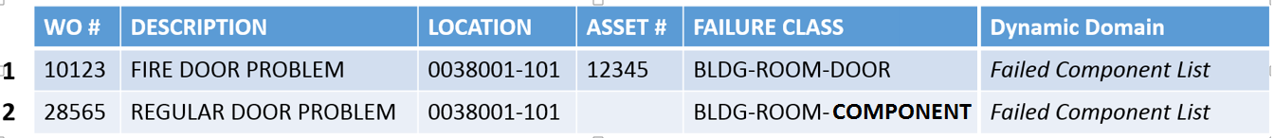
Figure 13 – Note the use of “COMPONENT” in third segment of Failure class
Line 1 | This is a work order linked to an asset – which is a fire door. The failure class would cross over from the asset to the work order.
Line 2 | This a door but only validated as a door with the failure class. The failure class would cross over from the location to the work order. The originator, requester or planner would need to change the BLDG-ROOM-COMPONENT to BLDG-ROOM-DOOR before APPR status.

Using a 3-Part Failure Class as Level-1
The failure class is stored in the workorder.failuecode field. Per the “rules of Maximo”:
- The location record Failure Class (locations.failurecode) would automatically crossover to the work order record.
- The asset record Failure Class (asset.failurecode) would automatically crossover to the work order record and override the crossover from location.
- The location record may have “COMPONENT” in the 3rd element meaning the gatekeeper (i.e. planner) populating the work order record must fill in the 3rd element.
3rd
Element
BLDG-ROOM-COMPONENT |  |  | Note: Any element with COMPONENT should be filled in before APPR status [This would be a business rule]
Example values for the 3rd element:
BLDG-ROOM-DOOR | Any doors accessing the room
BLDG-ROOM-WINDOW | Windows within the wall
BLDG-ROOM-SPACE | The whole central space of the room
BLDG-ROOM-HALLWAY | Hallway or corridor
BLDG-ROOM-STAIRS | Stairs between floors
BLDG-ROOM-ELEV | The elevator space
Example Failure Class (asset.failurecode) crossed over from an asset record to the work order:
UTILITIES-HVAC-BOILER | Asset is the boiler, and a boiler has parts that commonly fail.

Use Failure Class 3rd Element to drive Failed Component Values
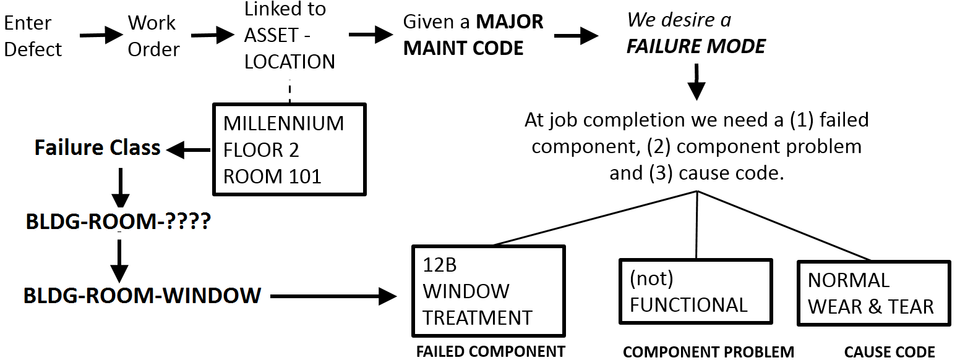
Figure 14 –Explaining Universal Failure Codes
The workorder.failuecode, 3rd element, would drive the failed component list. The system administrator will suggest a design for storing these failed components, but it is up to project team to make final decision. The important point is to have this as validated data and easy for users to select (i.e. minimal click-count).
FC-3RD-ELEMENT | FAILED COMPONENT
SPACE | FLOOR
SPACE | WALL
SPACE | CEILING
SPACE | LIGHTING
SPACE | TEMP
SPACE | AV EQUIPMENT
SPACE | FURNITURE/PODIUM
DOOR | ARMATURE PLATE
DOOR | ASTRAGAL CENTER
DOOR | BODY
DOOR | CLOSURE DEVICE
DOOR | CRASHBAR
DOOR | DOOR KNOB/LOCKSET
DOOR | FRAME/CASING
DOOR | GLASS
DOOR | HINGE
DOOR | LOCK JAMB
DOOR | SWEEP
DOOR | THRESHOLD/SILL
DOOR | VESTIBULE
DOOR | WEATHER STRIPPING
BOILER | ALARM
BOILER | CONTROL BOX
BOILER | DAMPER
BOILER | FAN MOTOR
BOILER | FLOAT
BOILER | FUSES
BOILER | GAUGE
BOILER | PIPING
BOILER | POWER SUPPLY
BOILER | PROBE
BOILER | PUMP, CIRCULATING
BOILER | TANK, EXPANSION
BOILER | THERMOSTAT/AQUASTAT
BOILER | VALVE, ACTUATTOR
BOILER | VALVE, BLOW-OFF
BOILER | VALVE, DRAIN
BOILER | VALVE, RELIEF
BOILER | WTR-TREATMENT

Other Combinations
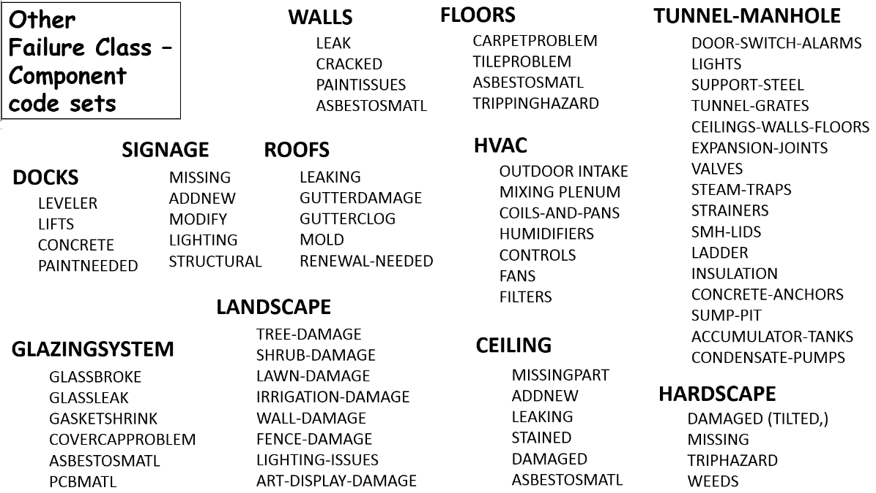
Figure 15 –Misc. Component-Problem Combinations

Use a Generic Code Set for Problem Codes
The assumption here is that the work order field for problem code applies only to the asset record. This field resides within the failure code hierarchy and would be used to store the problem of the asset. If the centrifugal pump stopped working, the problem code might simply be “FUNCTION” whereby the work order description would be more specific, and say, “Centrifugal pump stopped working”.

Below is a set of standard problem codes:
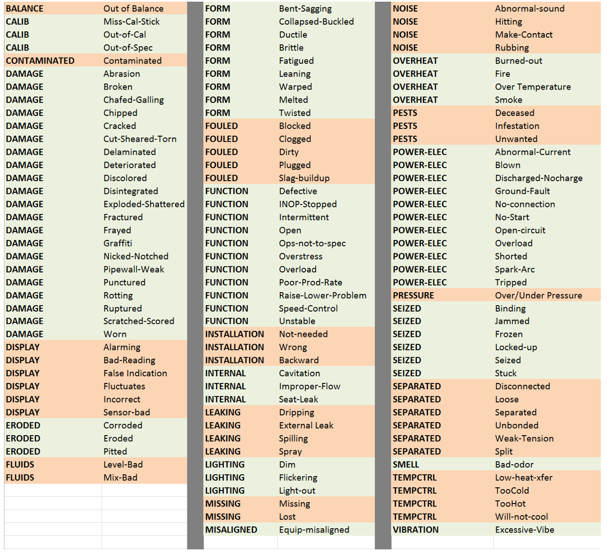
Figure 16 – Generic Problem Code List

Setup the Component Problem Code
This field could use the same domain as the asset problem code. Although the pump may have stopped working and be given (an asset) problem code of FUNCTION, the failed component might be IMPELLER and the component problem might be SEPARATED.

Setup a Cause Code Hierarchy
There may be a requirement to add three new fields for proper cause coding (i.e. Cause-1, Cause-2, and Cause-3). The benefit of three fields is that it allows a gradual drill-down on the issue plus it allows for different position/roles within the organization to enter values.
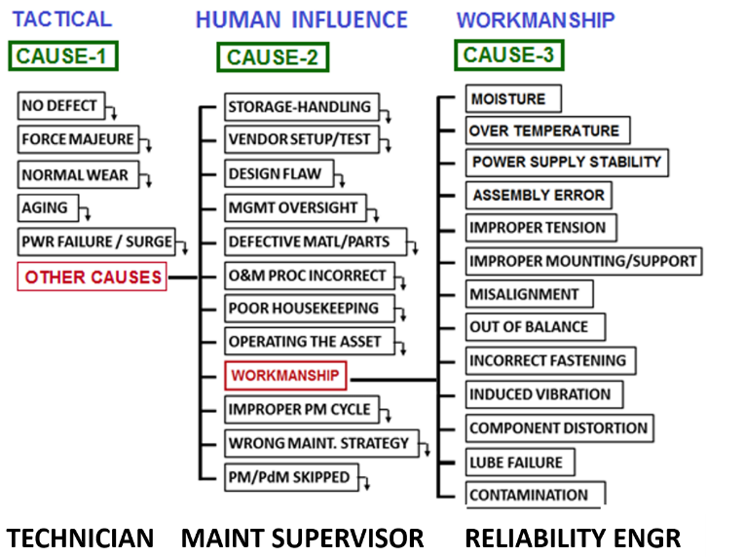  Figure 17 –Cause Code Hierarchy | The maintenance technician would procedurally be required at job completion to enter Cause-1. He could enter any of the “black” values and the process would stop there. If however none of the black values apply then he must enter OTHER CAUSES.  The maintenance supervisor would then be required to enter Cause-2 if Cause-1 = OTHER CAUSES.  The Reliability Engineer is a role that can be fulfilled by various staff members. This person has knowledge to derive root cause analysis.

Failure Analysis
Philosophically, one might ask where we stop, or how deep do we go? It is opinion of the reviewer that asset level failure coding is too high, plus, omission of a true failure mode does not help the reliability team extract meaningful information for decision making. As to going “too deep”, it would not be the intent of the CMMS failure data capture to perform corrosion analysis. The reliability team, however, may take the findings of the asset offender report and then decide to perform root cause analysis. Thus the chronic failure analysis process helps to (1) find the worst offenders, and then, (2) drill-down into the failure mode. Beyond that, an RCA or FMEA would be required.

Cause-4: Eliminating the real Defect
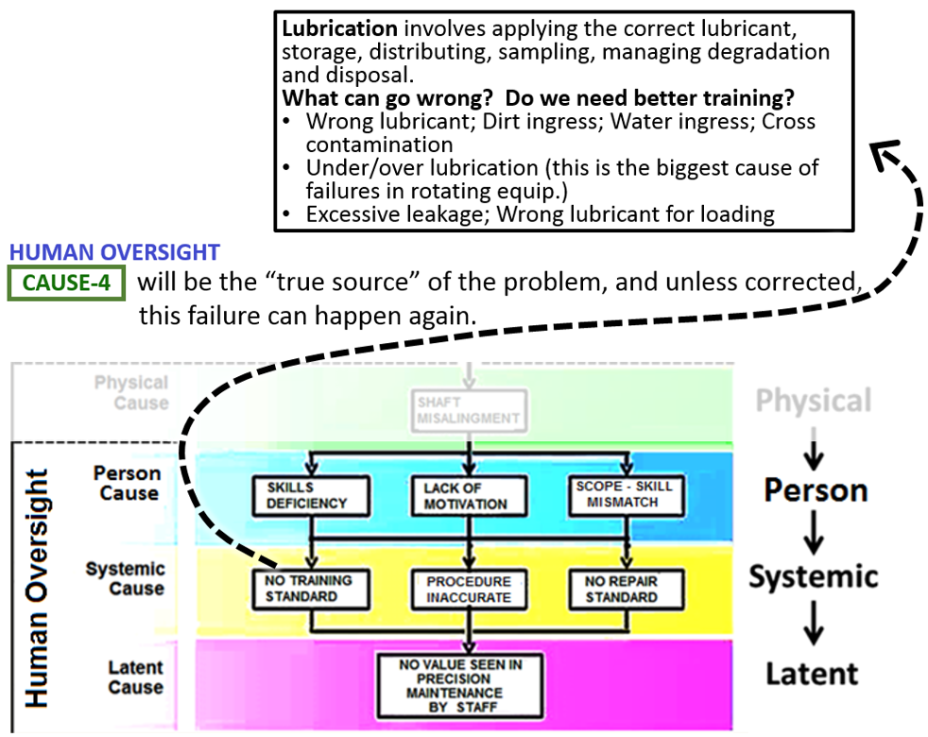  Figure 18 –Identifying Systemic Cause | For critical assets, the reliability team may ask the Maintenance Manager (or Supervisor) to conduct a 1-on-1 interview of the affected party.  From this discussion it will be determined how to proceed. It may be that he needs to schedule precision maintenance training for the entire crew.

Setup Remedy Codes
This list of remedies can be applied to any bottom level cause code. However, it is opinion of the reviewer to make this a standalone field on the work order with its own domain. | 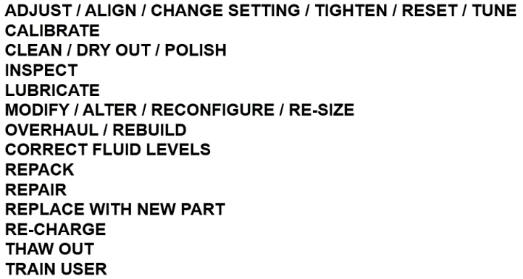  Figure 19 –Remedy Codes

Link work to Building Surge

Coding the Backlog
Work orders in the backlog (or minor defects) which is part of a building surge should have a link to the future maintenance period. The Building Surge Manager is responsible for scope, schedule, and cost control. The best way to do this is by adding a “marker” field on the work order record that only the Building Surge Manager can update (or his delegates). Or, you could make use of the Project Cost Tracking application with the creation of a WBS.

Work Order Categorization and Reporting Requirements
There can be several external and internal requirements for work categorization within the CMMS. Many organizations are required to create standard reports in standard formats. For PSU, the history behind the current major maintenance codes. The consultant believes these codes can be left in-place but there needs to be new coding standards implemented to capture the input needed for chronic failure analysis.
They are derived from CSI MasterFormat: https://www.csiresources.org/practice/standards/masterformat

They are useful because they align with construction activities/documents, like the PSU design standards:

https://wikispaces.psu.edu/display/OPPDCS/Design+and+Construction+Standards

This also defines our equipment acronym (nomenclature) standards: https://wikispaces.psu.edu/display/OPPDCS/01+01+00+PROJECT+DOCUMENT+FORMAT#id-010100PROJECTDOCUMENTFORMAT-.01GeneralOwnerRequirements

[per Ian Salada] However, there is no university policy nor regulatory requirement to use these codes. We can adjust them as needed, as long as we retain the business process functions.
[per Joseph Lonjin] Perhaps we can setup a new table which enables us to create a crosswalk between the various code sets of value and thereby report in multiple fashions.

Establish Building Selection Criteria
Some buildings will always have annual maintenance periods. And some buildings will never be considered for a maintenance period. There is a “middle grouping” which will be selected based upon selection variables.

Selection criteria provides transparency
These selection variables will result in a calculated ranking which will then be used to identify the next set of buildings. This calculation might be run once or twice a year. The following elements could be included in a calculation:
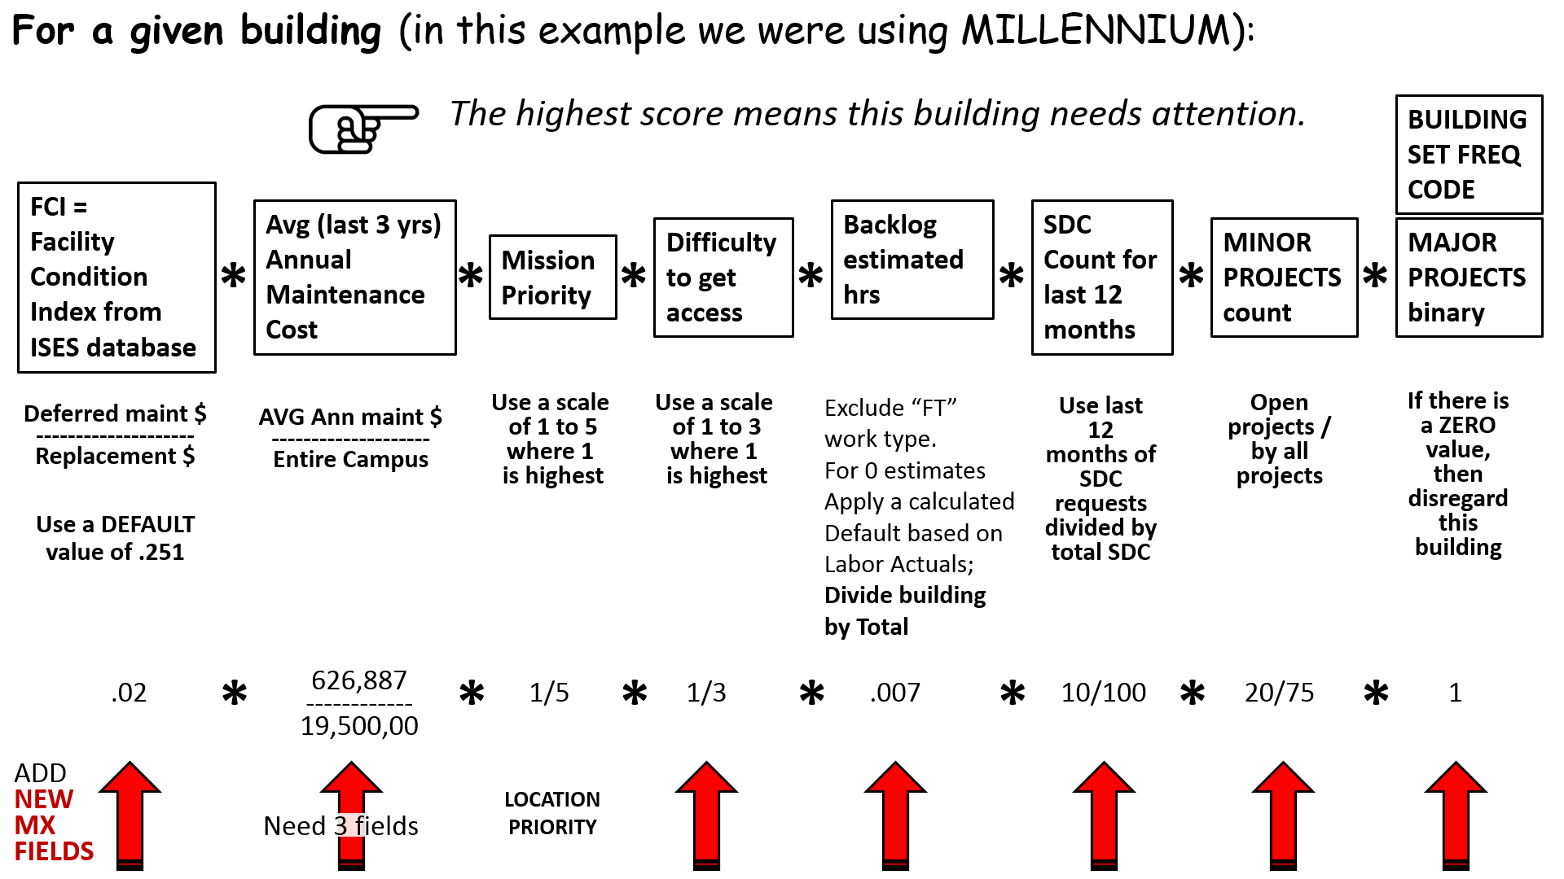
Figure 20 – Building Selection Criteria Formula

Some data may have to be extracted from external systems to populate the formula.

Technique to capture Average Annual Maintenance Cost
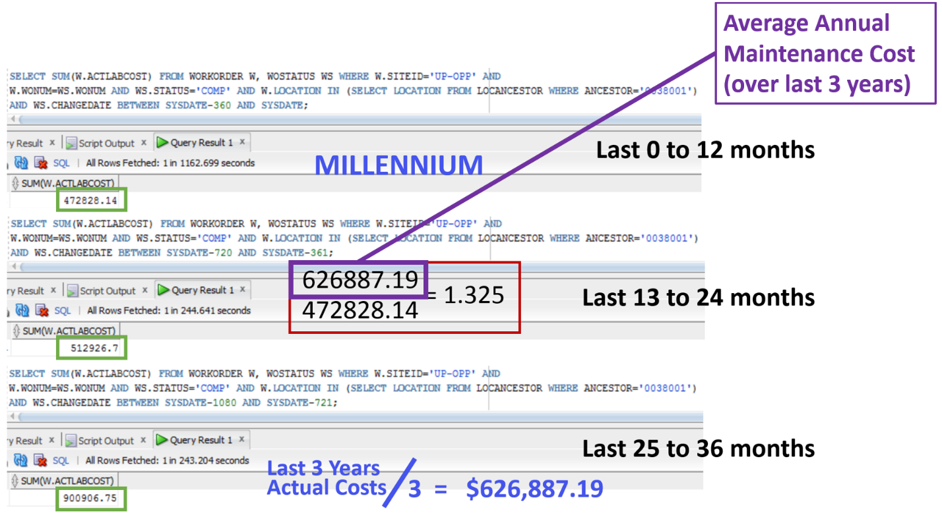
Figure 21 –Calculation example for Avg Annual Maint Cost / Replacement Cost

Technique to capture Estimated Backlog Hours
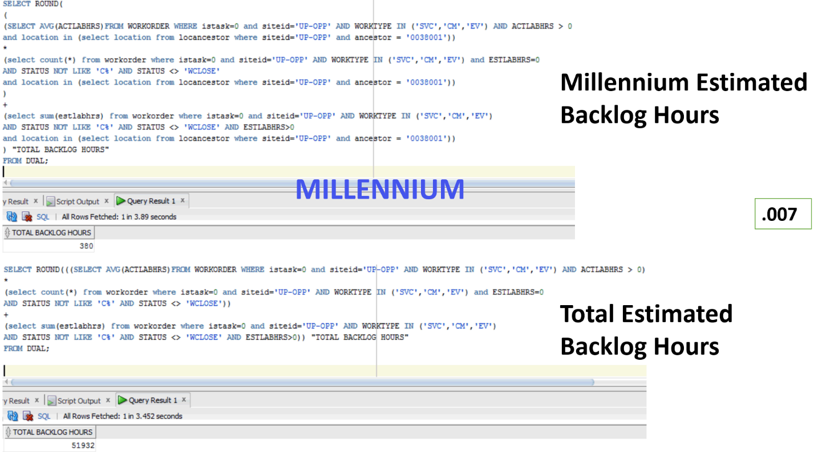
Figure 22 –Calculation example for Estimated Backlog Hours

Countdown Schedule

Single Building Countdown
Preparation for a given building surge should begin months in advance. The Building Surge Manager would be responsible for tracking these preliminary activities. An important milestone would be scope freeze as this then determines the resource and material requirements.
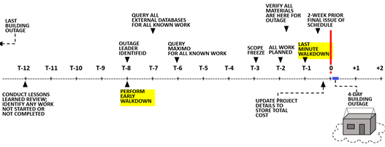
Figure 23 –Single Building Countdown

Multiple Building Countdown
A Building Surge Manager would be required to manage the logistics associated with multiple building countdowns.
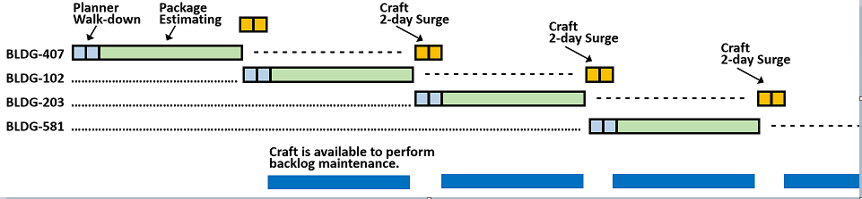
Figure 24 –Overlapping Surge Planning

A Walkdown Checklist
Within the facilities maintenance world, the periodic inspections whether time-based or in conjunction with a building surge preparation, are extremely valuable. The goal is to find the defect before the customer does. And in the worst case, the goal is to respond appropriately when they are reported (by customer). Perceptions are everything. If a prospective student visits a campus he may make his initial impression on campus layout, scenery, building condition, and in worst case, litter. And sometimes a defect can go un-noticed because it has been there so long.

Mobile device
Figure 25 –Mobile device with carry strap | Device Criteria:  A mobile device for recording defects would be ideal. This device would work indoors or outdoors. It could capture audio, pictures and text. Plus there would be prebuilt checklists.

Grading Condition
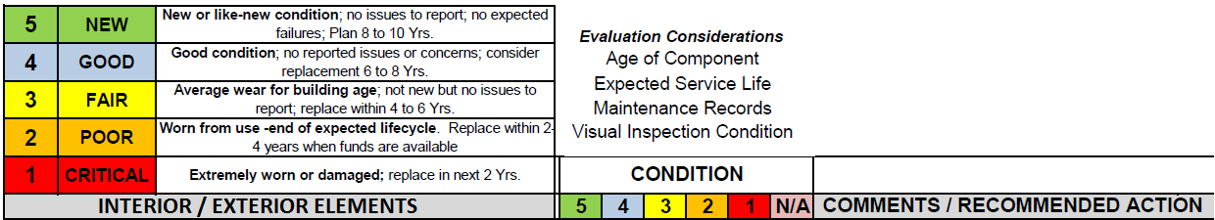
Figure 26 –Condition Grading Example

Generic Checklist Example
AIR DISTRIBUTION | DUCTING MATERIAL
AIR DISTRIBUTION | OUTSIDE AIR UNITS
AIR DISTRIBUTION | RETURN AIR PATH
AIR DISTRIBUTION | ROOFTOP ACUs
AIR DISTRIBUTION | TERMINAL UNITS
AIR DISTRIBUTION | VENTILATION AIRFLOW MONITORING
CLASSROOM TECHNOLOGY | AUDIO ENHANCEMENTS
CLASSROOM TECHNOLOGY | DOCUMENT CAMERA
CLASSROOM TECHNOLOGY | PROJECTOR/SCREEN
CLASSROOM TECHNOLOGY | STUDENT STATIONS (DATA+POWER)
COOLING-PLANT | CHILLERS
COOLING-PLANT | COOLING TOWERS
COOLING-PLANT | DISTRIBUTION PIPING
COOLING-PLANT | GLYCOL MAKEUP
COOLING-PLANT | MAKUP WATER
COOLING-PLANT | PUMPS
COOLING-PLANT | REFRIG ROOM MONITORING
COOLING-PLANT | WATER-TREATMENT
DEDCIATED AIRSIDE HEATING | AIR HANDLING
DEDCIATED AIRSIDE HEATING | DUCT FURNANCES
DEDCIATED AIRSIDE HEATING | HEATING-ONLY UNIT VENTILATORS
DEDCIATED AIRSIDE HEATING | UNIT HEATERS
DISTRIBUTED AIR HANDLING | BARD-TYPE UNITS
DISTRIBUTED AIR HANDLING | DUCTING MATERIAL
DISTRIBUTED AIR HANDLING | RETURN AIR PATH
DISTRIBUTED AIR HANDLING | SPLIT SYSTEMS
DISTRIBUTED AIR HANDLING | UNIT HEATERS
DISTRIBUTED AIR HANDLING | UNIT VENTILATORS
DISTRIBUTED AIR HANDLING | UNITARY SYSTEMS
DISTRIBUTED AIR HANDLING | WATER SOURCE HEAT PUMPS
DOMESTIC WTR HEATING | RECIRC PUMP
DOMESTIC WTR HEATING | WATER HEATERS
ELECTRICAL DISTRIBUTION | DEVICES (SWITCHES & RECEPTACLES)
ELECTRICAL DISTRIBUTION | FEEDERS
ELECTRICAL DISTRIBUTION | PANELBOARDS
ELECTRICAL DISTRIBUTION | TRANSFORMERS
ELECTRICAL DISTRIBUTION | TSS – SURGE SUPPRESSION
ELECTRICAL SUPPLY | MOTOR CONTROL CENTERS
ELECTRICAL SUPPLY | SERVICE SWITCHGEAR
ELECTRICAL SUPPLY | TRANSFORMERS, EXTERNAL OWNED
ELEVATOR | HALL FIXTURES
ELEVATOR | HOISTWAY PIT
ELEVATOR | INTERIOR CAB/SIGNAGE/EMERG-PHONE
ELEVATOR | MACHINE ROOM EQUIPMENT
ELEVATOR | OPERATING CONDITION
EXT-BLDG-WALLS | EXPANSION JOINTS
EXT-BLDG-WALLS | EXTERIOR FINISH
EXT-BLDG-WALLS | SEALANTS
EXT-BLDG-WALLS | SOFFITS
EXT-BLDG-WALLS | THERMAL CONDITION
EXT-CIVIL | ACCESS GATES
EXT-CIVIL | ADA ACCESS
EXT-CIVIL | CURBING
EXT-CIVIL | EMERG-VEHICLE-ACCESS
EXT-CIVIL | EQUIPMENT FENCING
EXT-CIVIL | LIGITS, MOTION DETECTORS, CONTROLS
EXT-CIVIL | LOADING DOCK
EXT-CIVIL | PAVING
EXT-CIVIL | PERIMETER FENCING
EXT-CIVIL | SIDEWALKS
EXT-CIVIL | SIGNS-POLES-LIGHTS(EXT)
EXT-CIVIL | STRIPING-MARKINGS
EXT-FACILITIES | ATHLETIC GROUNDS-DUGOUTS
EXT-FACILITIES | BLEACHERS
EXT-FACILITIES | CONCESSION-RESTROOMS
EXT-FACILITIES | DUMPSTER-COMPACTOR
EXT-FACILITIES | PE EQUIP STORAGE
EXT-FACILITIES | PLAYGROUND-PARK-AREAS
EXT-FACILITIES | POOLS
EXT-FACILITIES | SCOREBOARDS
EXT-FACILITIES | WALKWAY CANOPIES
EXT-LANDSCAPE | BIKE RACKS
EXT-LANDSCAPE | EXTERIOR FURNITURE
EXT-LANDSCAPE | IRRIGATION
EXT-LANDSCAPE | LANDSCAPE VEGETATION
EXT-LANDSCAPE | LANDSCAPE WALLS-STRUCTURES
EXT-LANDSCAPE | PATIO SYSTEMS
EXT-LANDSCAPE | TREES
EXT-ROOFING | DRAINS+GUTTERS+DOWNSPOUTS
EXT-ROOFING | ROOF EQUIP CURBING
EXT-ROOFING | ROOF OPENINGS (I.E. SKYLIGHTS, ACCESS)
EXT-ROOFING | ROOF SURFACE (LEAKS, PONDING)
EXT-UTILITIES | BACKFLOW PREVENTER
EXT-UTILITIES | ELECTRICAL SERVICE
EXT-UTILITIES | GAS DISTRIBUTION
EXT-UTILITIES | LIFT STATIONS
EXT-UTILITIES | SANITARY
EXT-UTILITIES | STORM WATER MGMT
EXT-UTILITIES | VOICE-DATA SYSTEM
EXT-UTILITIES | WATER DIST
HEATING-PLANT | BOILERS
HEATING-PLANT | E-STOP
HEATING-PLANT | MAKEUP WATER
HEATING-PLANT | PIPING
HEATING-PLANT | PUMPS
HEATING-PLANT | WATER TREATMENT
HVAC | CONTROL-SYS
REFRIGERATION SYSTEMS | COOLER
REFRIGERATION SYSTEMS | FREEZER
REFRIGERATION SYSTEMS | ICE MACHINE
STAIRS | HANDRAILS
STAIRS | LANDING FINISH
STAIRS | STAIR NOSINGS
STAIRS | STAIR TREADS
TOILETROOMS | FLOOR
TOILETROOMS | PARTITIONS
TOILETROOMS | SIGNAGE
TOILETROOMS | SINKS
TOILETROOMS | URINALS
TOILETROOMS | WALL
TOILETROOMS | WATER CLOSETS

Utilize Failed Component List to drive Building Walkdown Checklist
Once the failed component listing is created then you can create a checklist by failure class 3rd element.
Figure 27 –Checklist references common failure modes
- During the WALKDOWN process, OPP staff should also interview OCCUPANTS, CUSTODIAL, AREA TECHS, and AREA SERVICE DESK (four total)
- The objective is to look for problems that somehow got missed. If this staff was interviewed post outage, you wouldn’t want them to mention a problem they knew about all along – but no one asked them about.
- Carefully record these issues & defects.

Validate Installed Equipment (identified in Maximo)
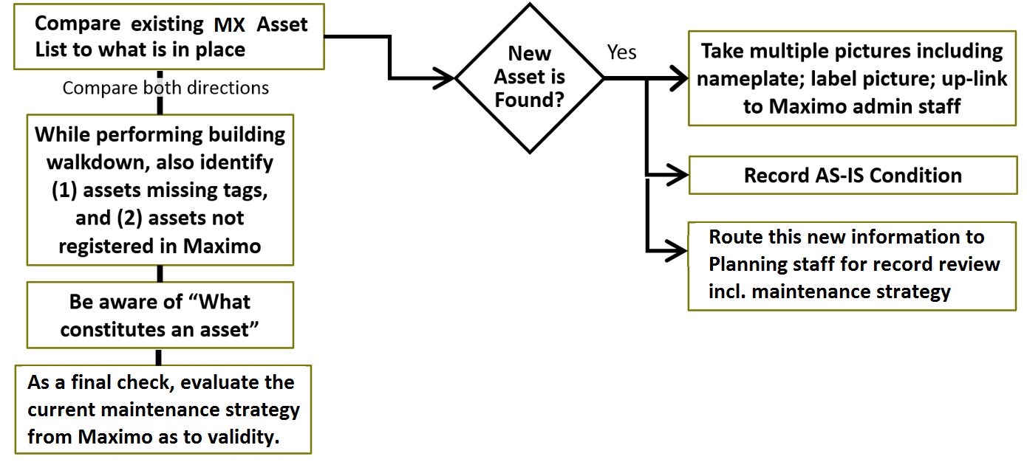
Figure 28 – Validating equipment tags

Build a Detailed Schedule
Activity scope should be determined by any outstanding Shutdown Requests, open backlog (marked for building surge), conversation with Facility Coordinators and Walkdown discovery (defects). The schedule should be built with logic ties, and resource leveled. Materials should be planned and staged.

Schedule Activities should have Calendar attribute
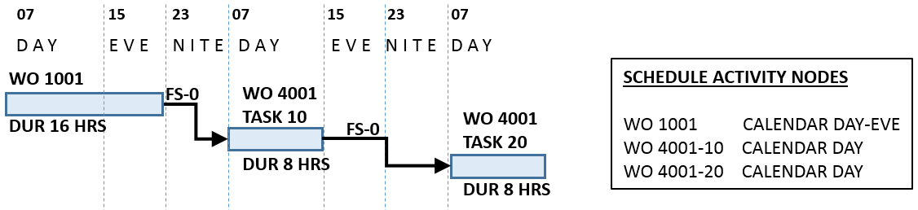
Figure 29 –Activities in Schedule with different Shift-Calendars

Progressing Reporting should be flexible
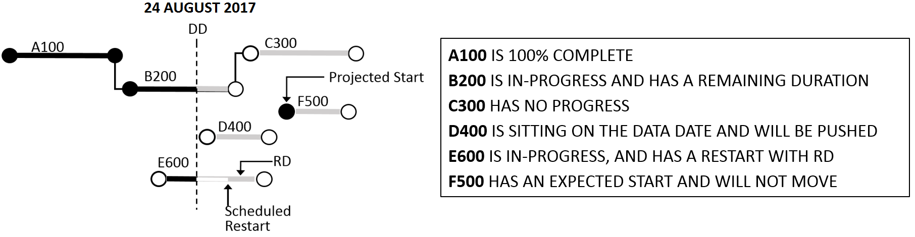
Figure 30 –Various options of progress reporting

Schedule Fundamentals
- All known/possible work is initially considered for analysis: Scheduler should review all possible sources of work including information from other databases/files, walk-downs and Facility Coordinator (and other) interviews.
- For the above identified work, this should be entered in the CMMS as either work orders or deficiency records [Note: may need new application for tracking Deficiencies-Defects-Deferred Maintenance].
- All identified work should be prioritized and resource estimated.
- Material requirements should be estimated.
- PM work that is due during the outage time-frame should be identified.
- All of the above work should then be transferred to the scheduling software.
- All activities should be linked to a working calendar (ie. day time, or day+evening, or 24/7)
- Where applicable, logic ties should be entered.
- Where applicable, constraint dates should be entered [Note: use constraints only when logic ties not useful or there is a required "ON" date to be adhered to]
- Critical path should be determined - which drives duration length.
- Craft resource pool should be identified. [Note: in addition to duration limit, the craft calendar availability will restrict scope]
- Perform automatic resource leveling based on Priority. This process will indicate probable overflow (i.e. more work than duration limit can accommodate). The scheduler then cuts the overflow work and erases the WO record OTG CODE from "0038001-20170731" to either NULL or "0038001-FUTURE".
- Hold "first-cut" schedule meeting. Incorporate refinements.
- Share schedule with all affected parties and stakeholders.

Stage Materials for Repair and Construction
A staging area is a physical location used for the storage of construction related equipment and materials such as vehicles and stockpiles. It could be in an open area or (more likely) in a locked room such as the mechanical room. The objective is to minimize trips to the warehouse by having all known materials procured and delivered in advance of building surge.
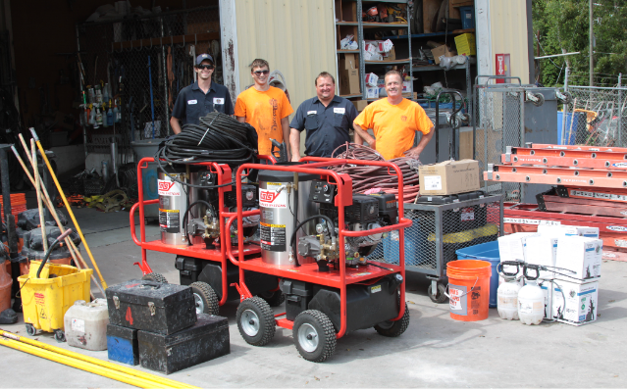  Building Exterior | Mechanical Room
Figure 31 –Pictures of possible staging locations

Customer Satisfaction
It is important to get every possible bit of information from the customer (academia, facility coordinators and even students) as to possible defects. These should be entered into Defect Tracking and linked to the building. It also helps to fully advertise the event in advance and even consider placing work schedules on each floor.

PR Campaign
- Responsibility: Building Surge Manager
- Create posters for the above actions, to place in Area Shops and OPP bldg
- Put specific wording into the WO plan steps when necessary to take pictures before – and after
- Capture condition-based technologies, readings/pictures before and after
- PR summary document issued from AVP Physical Plant, at 30 days post outage
- Identify hidden failures that were corrected, or with scheduled corrective actions and cost avoidance (ie impact cost)
- Publicize completion of the TOP 10 work activities as to significance/impact
- Safety improvements (if applicable)
- Count of overall work orders performed; percent planned vs performed
- Utilize electronic messenger to announce surge countdown and publicize after-the-fact
- Presentations at internal staff meetings, Supervisor huddles, and FC meetings

Conduct a Lessons Learned Review
- Procedure not followed; safety hazard incident
- OPP Outage Staff not trained or properly briefed for outage
- Under-estimated the jobs
- Final walk-thru
- When needed, planner reserve tools
- Customer didn’t fully understand scope
- Status update meetings were not held, or poorly held.
- Outage Leader should send summary status memo
- Facility Coordinator rep should be limited to 1 person per college
- Stall stories
- Materials not there (Planner responsible for entire process)
- Unplanned events occur – what to do:
  - Consider 3rd shift
  - Consider contractors
  - If none of the above possible, then cut work…
- Work completed – Work left partially done – Work not started
- Work which went badly
- Get (positive) feedback – and convert to written format (could be survey)

The Benefits of work bundling
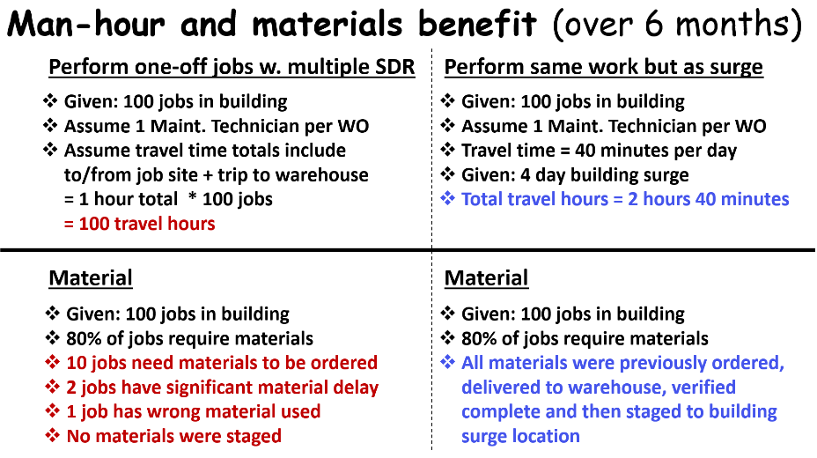
Figure 32 – One-off jobs versus Work Bundling
With work bundling staff can improve backlog reduction by doing more work in a shorter period of time by utilizing pre-planned work packages with careful sequencing of work. The selected work scope would be limited by outage duration, craft skills, craft availability, needed materials, "elbow room", and logical sequencing of work (i.e. paint last) to get the right people doing the right work.

It is also careful planning and scheduling that minimizes rework and reduces errors (work scope and job safety). And by focusing on "worst building first", we are managing by exception. Lastly, by working closely with building facility coordinators throughout the process, we ensure that their building is maintained in optimum condition.

With the new capability of defect tracking with automated rough estimate calculation, now leadership can run a report to see all known work – plus deferred – and output as total cost.

Process and Roles

Process Flow – with Statuses
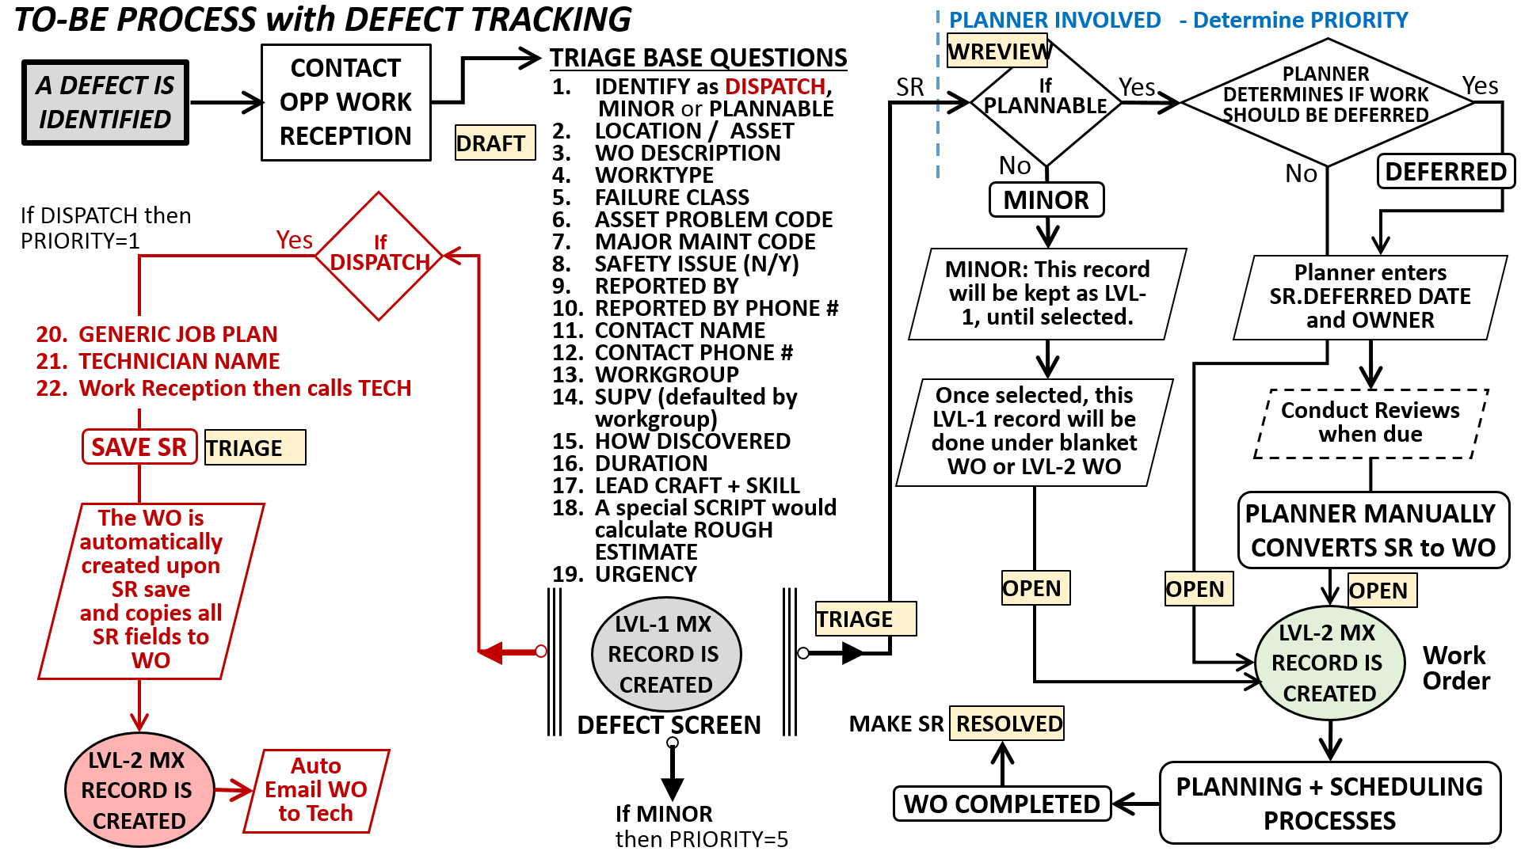
Figure 33 –Process Flow with Status Changes

Roles and Responsibilities - Suggested
Building Surge Coordinator | This role would be responsible for overall scope and schedule control, walk-downs, work force selection, and customer satisfaction. This would include post maintenance period review and lessons learned as well as any advertisement of accomplishments.
Scheduler | Yes, it’s possible to maintain a schedule within a Word document, but the creation of a real schedule offers many more benefits. These benefits include: craft estimating balanced against availability; critical path management; progress reporting; and graphical schedules (bar charts) for customer notification.
Warehouse Coordinator | The Building Surge Coordinator, Scheduler, and Planner staff would work closely with the Warehouse Coordinator to identify required materials per the frozen scope, and track them all the way to delivery – including the staging point. Logistics need to be worked out for the Vendor to notify in advance the delivery time so that OPP-WCD staff can be present to unlock the room.
Director Work Control | Procedure-Directive for Building Surge which includes selection criteria formula. And the periodic building selection recalculation. Procedures are always a good thing and would describe requirements, responsibilities, output documents, customer notification, and expectations. Example of areas where procedures are needed:  - Minor defects when discovered should normally be remedied during that visit. However, in some cases, this is not possible due to material requirements or resource availability.  - Minor defects, which were discovered, should be documented inside the CMMS system. This can be done three ways: in the (new) defect tracking screen as individual entries, or, as part of a blanket work order, or as a new work order.  - In some cases, a defect may be categorized as Deferred Maintenance – inside the Defect Tracking screen.  - The walkdown process.  - Schedule: Progress reporting
Work Reception | After being trained on the new Defect application, they would enter values into the new-required fields.
Maximo Core Team | Setup/administration of the new Defect Entry screen and defect reporting.

Discussion on Possible System Configuration

Work Reception Entry Screen
Some modifications may be required to the existing screen to accommodate new categorizations.
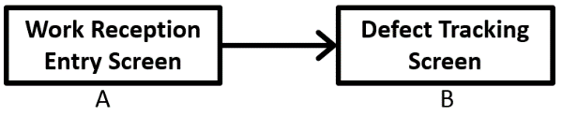 | These could be separate screen-applications or they could be combined. This decision is not known at this time.

New Defect Tracking – Field Requirements
This application can be created new - or inserted into the existing Service Request application. It may be that this functionality is combined with the existing work reception Maximo entry screen. This would be the decision of the site Core Team.
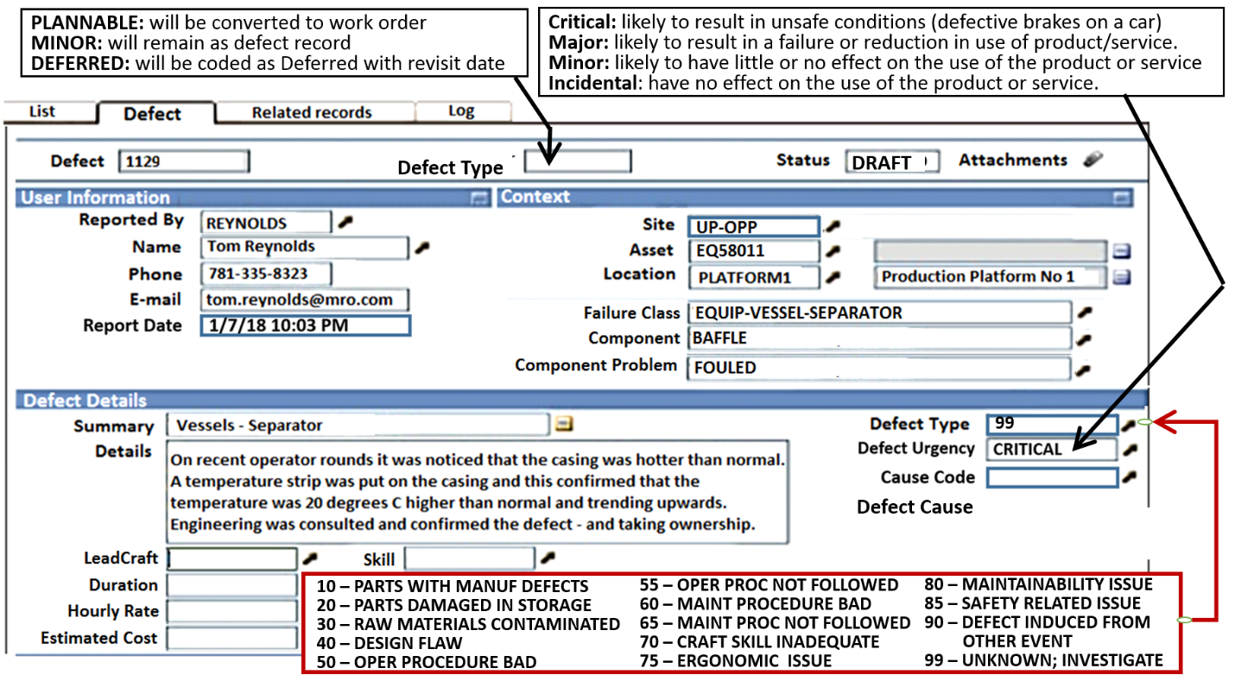
Figure 34 –Nine Point Program in Process Order

Failed Component and Component Problem Relationship
There needs to be a repository in Maximo to store this relationship.
See the below discussion on TYPE OF WORK.

Automatic Rough Estimate
For this calculation to work, specific entry fields must be populated early in the process.
TYPE OF WORK  REPOSITORY | The Type of Work repository is needed, and defined as the  Failure Class 3rd element || Failed Component || Problem Code  (DOOR || LATCH || FUNCTION)  which is then linked to  LEADCRAFT || SKILL, plus DURATION, and when combined, has an HOURLY RATE.  As mentioned in earlier discussion, the Failure Class field originates on the Location or Asset record. It crosses over to the work order. For an asset record, this value might be BLDG-ROOM-DOOR. For a Location record, this might be  BLDG-ROOM-COMPONENT.  For the later, the Planner (or similar role) must replace the “COMPONENT” with appropriate equipment value – not to be confused with the failed component. It is the 3rd element of this Failure Class which drives the failed component list.
ROUGH ESTIMATE CALCULATION | The Hourly Rate is extracted from the Type of Work table and multiplied times the DURATION to get a Rough $ Estimate. The person entering the defect record  must therefore provide a  Duration, LeadCraft and Skill. This must be an automatic calculation.

Go-forward Action Plan
The following content is a suggested action plan. The first course of action would be for the Core Team to review this total list and discuss internally to verify (1) Suggestion makes sense, (2) Does it need altering?, (3) Who will be lead?, and (4) Should there be a target date?
F# | Future State Element | Current State of Element | What is the Gap? | Recommended Actions
(1) | One of the primary objectives of this project scope was to formalize the Maintenance Period event. | The Maintenance Period is mostly informal. The procedure document is not fully created. | (1.1) Maximum work is not performed for the allotted window.  (1.2) No formal scheduling tool is used.  (1.3) A role for work bundling coordination should be clearly identified. | (1.1.1) All work in open backlog should be considered, including known defects.  (1.2.1) A scheduling tool should be used to create a countdown and detailed schedule (resource balanced) for the maintenance period.  (1.3.1) Document this role. Insert into WCD procedures.
(2) | A formal walkdown checklist based on likely problem codes would help the inspector identify issues. | Inspection process is mostly informal. | (2.1) A checklist based on likely failed components is missing.  (2.2) Electronic medium for capturing problems is not available. | (2.1.1) Complete build-out of universal failure codes using examples in this document  (2.1.2) Extract likely failure modes and place these on checklist  (2.2.1) Conduct search for ideal mobile solution (hardware & software)
(3) | Have ability to track defects as well as deferred maintenance inside Maximo | Other than log notes, there is no way to formally capture defect records. | (3.1) Defect tracking documents the defect including cost estimate. | (3.1.1) Create application for Defect Tracking.  (3.1.2) Create process/procedure with roles/responsibilities for defect tracking.
(4) | Have ability to capture automated rough estimates for both defects and work orders. | No ability currently exists. | (4.1) At any given moment there can be large number of unplanned work orders. This impacts ability to extract estimated size of backlog. | (4.1.1) Create table (application) to store FAILURE MODE, LEADCRAFT, SKILL, HOURLY RATE.  (4.1.2) Create automation script that auto calculates the rough estimate based on FAILURE MODE, LEADCRAFT, SKILL, DURATION, and HOURLYRATE. The user would enter the FAILURE MODE and DURATION and a background table would provide the other values. An example of failure mode would be: DOOR-LATCH-FUNCTION
(5) | Need transparent calculation which identifies the order of buildings needing annual maintenance periods. | A rough formula has been designed (see inside this document) but this needs to be proceduralized. | (5.1) The calculation should be part of the new work bundling procedure. | (5.1.1) Describe each value as to where it can be found and stored.  (5.1.2) Be able to demonstrate calculation.
(6) | Formalized process for setting up staged materials exists | This seems to be mostly informal at present | (6.1) A person in charge is not yet identified. Material tracking seems to be left up to the trades. | (6.1.1) Document material staging process inside WCD procedure as it pertains to maintenance period events.

