OPP-TB-253519.100
Control Valves
PICCV Valve Programming

Background
Pressure independent control valves are used in place of standard characterized control valves where system pressures may vary greatly, causing valve fluctuation and premature failure.
Some valves are shipped with an internal software limit that prevents the valve from opening fully during the BAS chemical treatment circulation routine. These valves must open fully for the cycle to be effective. Any limitation in the valve travel should be done at the BAS level.
There are three valve sizes commonly found at terminal units, ½” low flow (up to 2.5 gpm), ½” high flow (up to 5.5 gpm), and ¾” (up to 10 gpm).
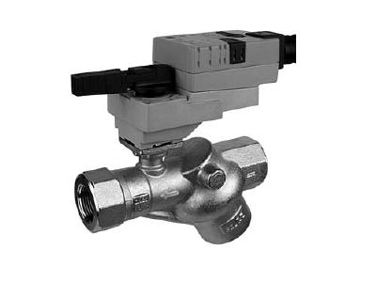
Diagnosis
PICCV valves are identified by the wye pattern of the valve body, and the ¼ turn actuator.
Command the valve to 10V in the control system, and note the actuator position. If the valve position is not at 100% open, proceed to the corrective action.
Corrective Action
All work must be coordinated with a BAS analyst to maintain consistency in the control logic.
Note the original valve tag information such as model number and design gpm.
Connect to the control valve with the Belimo ZTH valve tool.
Note the operational gpm setting, valve % open, control signal (2-10V) within the valve, and reset the value to the highest allowable flow rate, which is dependent on the valve size (2.5, 5.5 or 10 gpm).
Provide the BAS analyst with the valve location, valve tag information, original and final flow settings, the valve % at the original setting, and coordinate the control signal range.

Publisher: Penn State University, Office of Physical Plant, Energy and Engineering Division, Engineering Services
Editor: Stephen Oskin, Continuous Commissioning Engineer, Ph: (814) 867-4715, email: seo110@psu.edu
Last Revision: March 8, 2013

