OPP-TB-238216.050
Coils
Freezestat Installation

Background
Freezestats (low-limit thermostats) are typically installed on hydronic coils to protect coils and related systems from freezing and bursting. The sensing element in the freezestat is a vapor-filled capillary tube, typically 2mm (diameter) copper. If the temperature of any 1-foot portion of the capillary tube falls below setpoint, the vapor begins to condense causing a rapid pressure drop within the tube and tripping the switch.

Diagnosis

Perform visual inspection of freezestat and element and perform corrective measures if any of the following conditions are discovered:
- A vertical serpentine mounting arrangement of the element. Vertically mounted portions of the sensing element can allow undetected cold spots. When too much of the element is mounted vertically, improper operation results.
- The sensing element is too sharply bent, kinked, strained, or pinched, or has been rubbing against other metal surfaces.
- Extra element recoiled/wrapped up at the TAIL end (opposite the controller). It is acceptable to have some unused portion of the element uncoiled at the controller end.
- Controller case, bellows, and/or unused element located exposed to unheated conditions that can fall below the freeze protection setpoint (approximately 35 degrees F.).
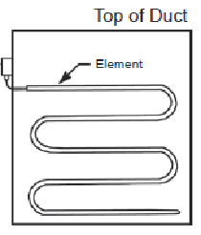
Figure 1 – Element Mounting

Corrective Action

Remove existing thermostat and sensing element. Do not attempt to repair or reuse damaged components.

ALWAYS carefully read and fully follow the specific manufacturer’s installation instructions. Failure to follow them could result in damage to the freezestat or failure to operate and protect the associated equipment and facility.

The following guidelines are meant to supplement, not take the place of the manufacturer’s installation instructions:

IMPORTANT: Locate controller case and bellows where ambient temperature is always warmer than the freeze protection setpoint.

Install new element in a horizontal serpentine pattern (refer to Figure 1) so that it is exposed as uniformly as practical to all areas where low temperature is possible. Provide a minimum of 1 foot of sensing element for each 1 ft² of coil area. At that ratio, the element covers a maximum of 6 inches above and below and from the return end. Starting at the bottom, the row with the tail end of the sensing element shall be a maximum of 6 inches from the bottom of the area to be sensed with the next row 12 inches (maximum) above the last. Then work back to the body of the unit. The top row shall be installed a maximum of 6 inches from the top of the area to be sensed. The maximum spacing dimensions may be reduced in order to achieve uniform coverage and have the controller body end on the most accessible side of the application. NOTE: Uncoil only the amount of element needed for the application. Starting from the controller body and working to the end of the tail often results in ending up with extra element and the tendency is to just wrap the tubing back on itself in the airstream, which is not correct.

The capillary tube element is delicate. Care should be taken to install properly to ensure there are no sharp bends, kinks, strains or pinch marks in the element and with the approved turning and mounting devices. Never create bends that are smaller than the manufacturer’s minimum bend radius requirements. Manufactured mounting clips* with built in bend radius shall be used wherever working space allows DO NOT PULL on the element. Failure to carefully comply may render the element ineffective, resulting in a burst coil.

Tie up the capillary element at appropriate points to prevent damage from air movement or vibration. Ensure that fasteners used to secure capillary tube do not pinch or kink the tube, but are secure enough to prevent excessive vibration of the element.

Never allow the element to rest against sharp edges or rub against metal surfaces. Install a rubber grommet or bushing where the sensing element enters the case to seal the opening and protect element from vibrational wear. Airflows within the unit's casing can cause the element to vibrate and damage itself.

Allow unrestrictive access to the manual reset button.

*Preferred element mounting clips (OPP Stores Stock #425869):
JCI
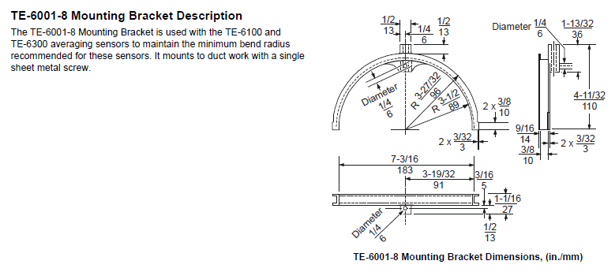

Publisher: Penn State University, Office of Physical Plant, Energy and Engineering Division, Engineering Services
Editor: Scott Rhoads, Facility Mechanical Engineer, Ph: (814) 865-1287, email: swr101@psu.edu
Last Revision: August 5, 2015

