OPP-TB-232116.100
Dielectric Connections
Dielectric Unions and Nipples

Background

Whenever a ferrous metal such as black steel is connected to a non-ferrous metal such as copper, a dielectric connection must be installed to prevent galvanic corrosion. The installation of a fitting with inert material between the two metals prevents the flow of electrons between the metals, preventing premature failure of the piping.

Traditionally, dielectric unions (see pictures at right) have been installed to perform this function. However, dielectric unions are proven sources of leaking fittings, and should be avoided. When the fitting leaks, the standard temporary fix has been tightening the fitting. This squeezes the rubber seal, making the seal less elastic, or the two metals make contact (see cutaway photo). As the system temperature changes, the fitting is then more prone to leaking. The cycle is repeated until the fitting is removed, or enough corrosion is present to prevent system leaks. An alternate approach is to keep the heating system at elevated temperatures, which is a costly approach to combat an easily-rectified problem.

Diagnosis
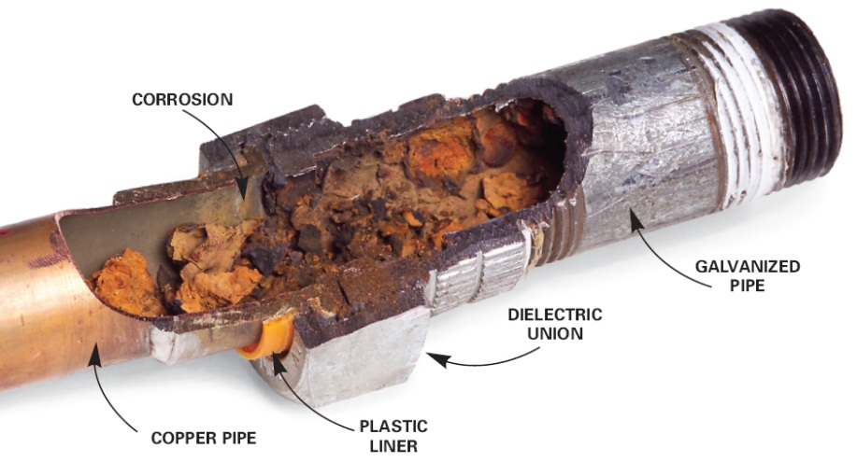
- Inspect leaking fitting for ferrous and non-ferrous metals.
  - Ferrous Metals
    - Black Steel
    - Malleable Iron
    - Cast Iron
    - Stainless Steel
    - Galvanized Steel
  - Non-Ferrous Metals
    - Copper
    - Brass
    - Aluminum
    - Bronze (dielectric connection is not required if installed with steel on either side)
- As shown in the photo, external corrosion may not be present, and therefor is not a requirement for replacement.

Corrective Action
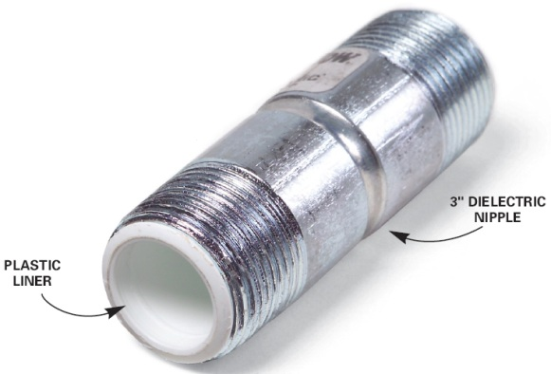
- Remove the dielectric fitting, and replace with a dielectric nipple*.
- If required, install a new union on a continuous section of piping material.
  - Copper Piping = Bronze Union
  - Steel Piping = Steel, Cast or Malleable Iron
- Never install dielectric unions.
- A chart showing the properties of common metals has been attached for your convenience. The further apart that the two metals are, the higher the rate of corrosion. The more anodic metal (right side of the chart) will “sacrifice” material to the more cathodic material.
  - i.e. If titanium and aluminum were in contact, the titanium would be unharmed, and the aluminum would have aggressive corrosion.

*Important: Perform all welding or soldering prior to installation of the nipple. Excessive heat will melt the plastic liner and block the pipe.

Publisher: Penn State University, Office of Physical Plant, Energy and Engineering Division, Engineering Services
Editor: Stephen Oskin, Continuous Commissioning Engineer, Ph: (814) 867-4715, email: seo110@psu.edu
Photo Credits: www.askmehelpdesk.com, www.familyhandyman.com, www.corrosionist.com
Last Revision: August 21, 2013

