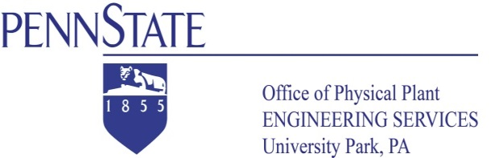
Technical Bulletin OPP-TB-23 21 13.100
Cooling Coil Condensate Drains
Proper Trapping

Background

Incorrect condensate piping can create several unwanted operational issues ranging from carryover, and ponding, to overflow and non-flow conditions. The attached bulletin addresses most major condensate issues, the appropriate solution.

Diagnosis/ Correction:

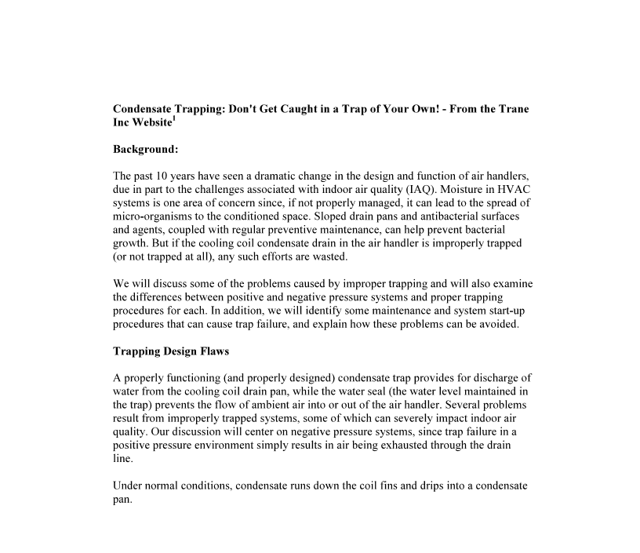

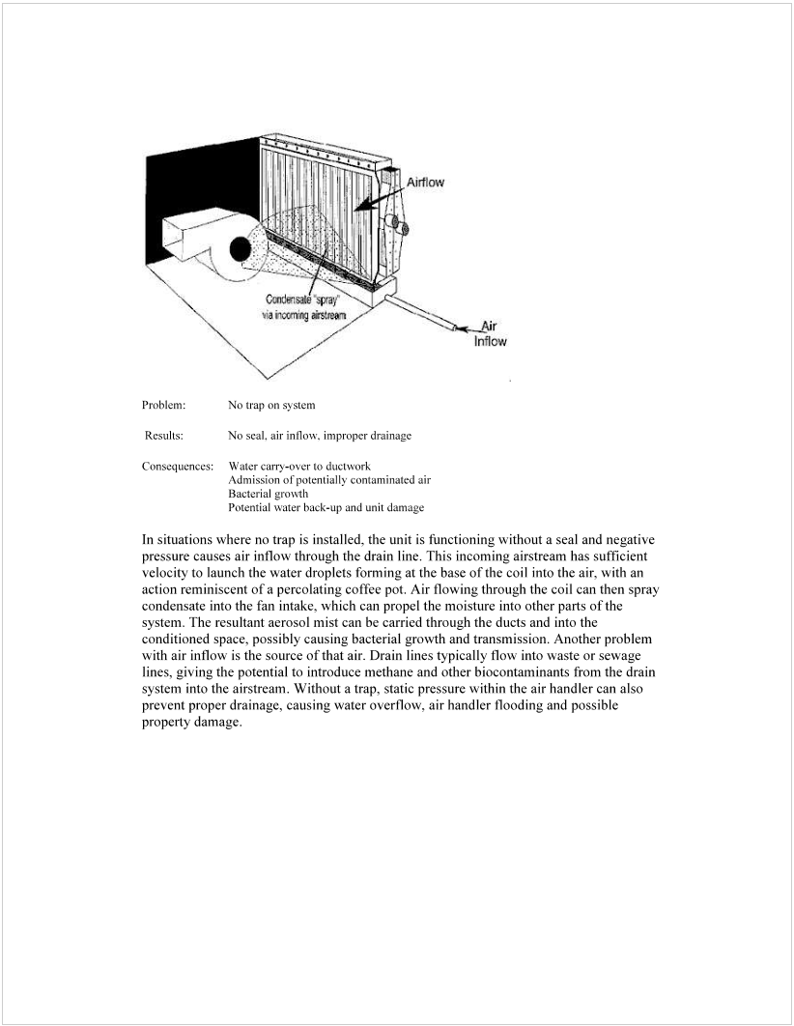
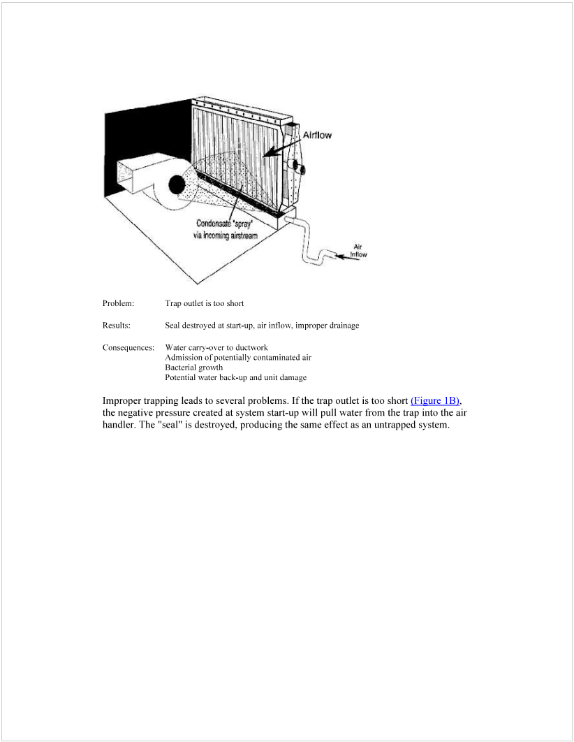
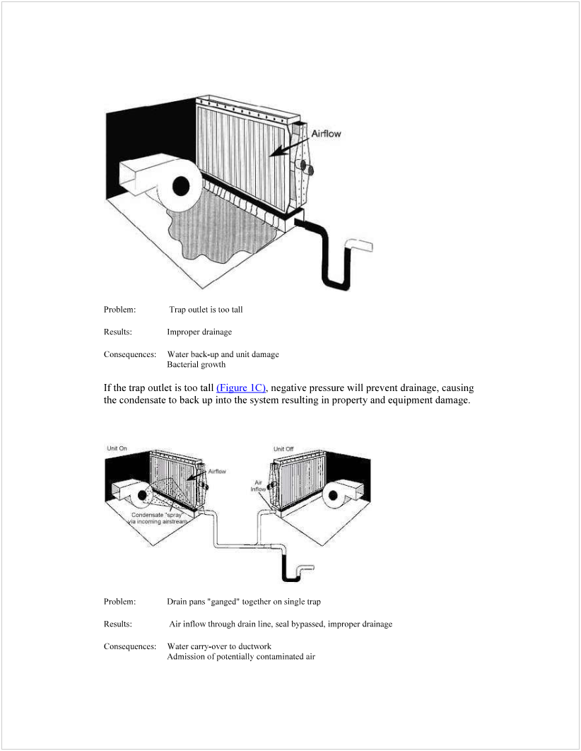
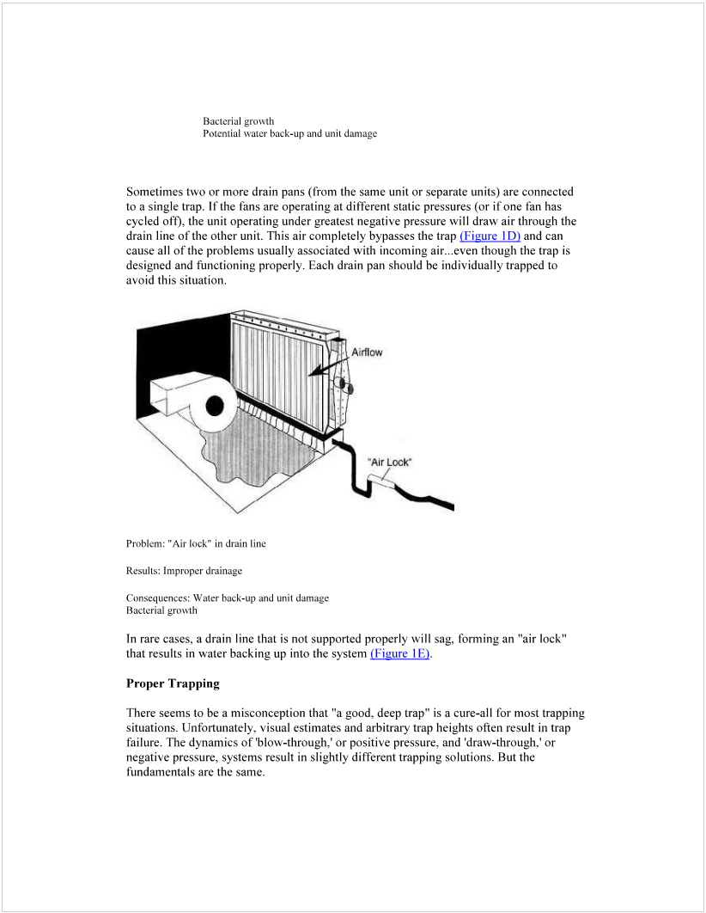
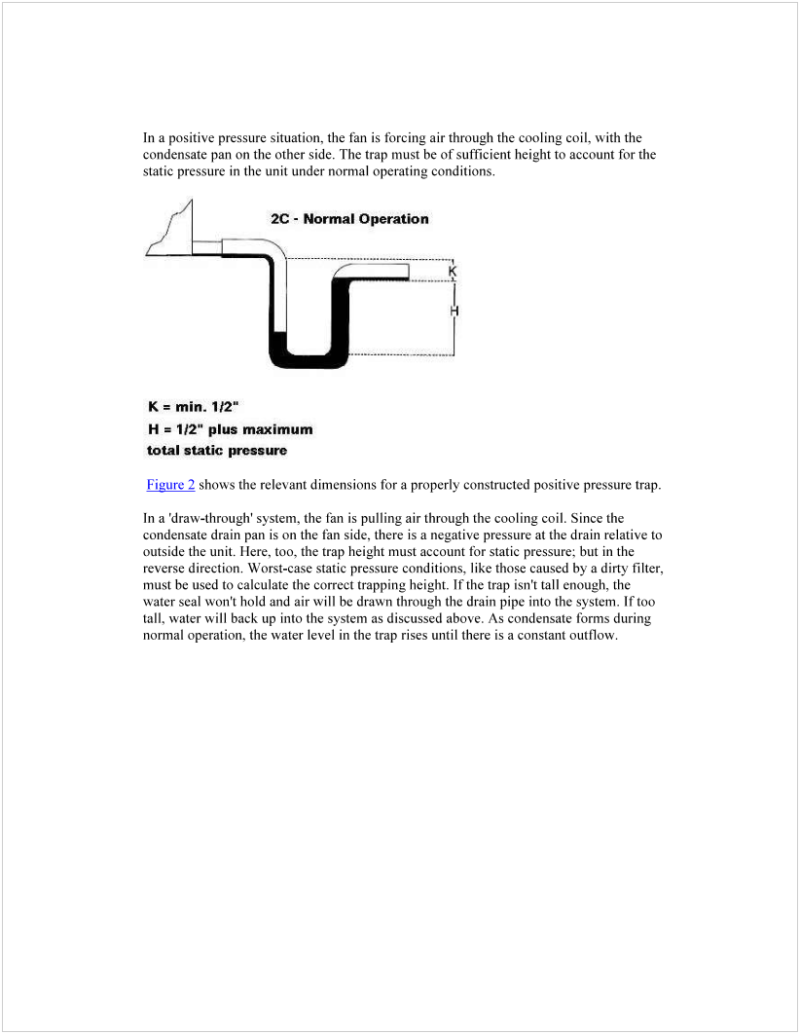
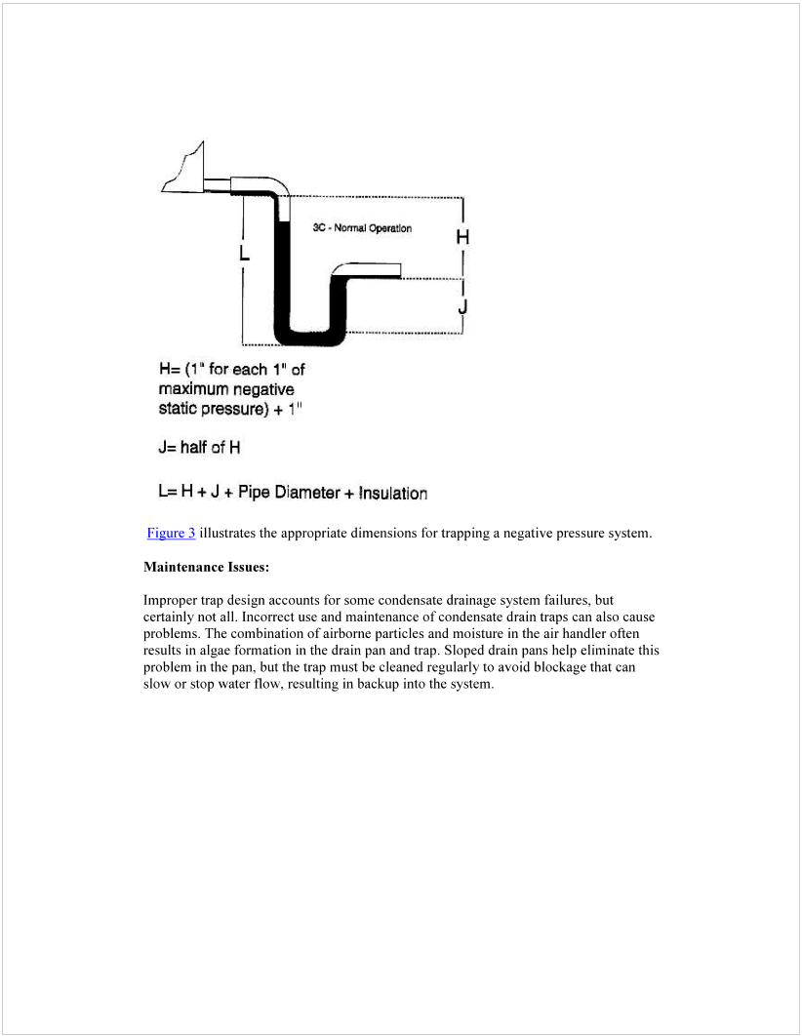
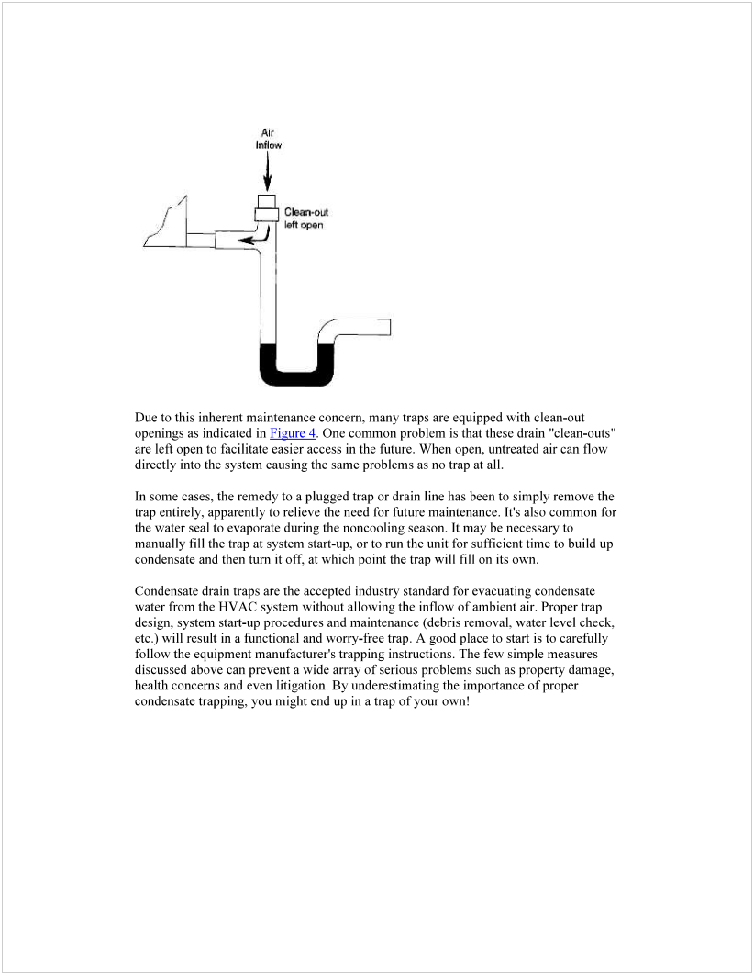
Publisher: Penn State University, Office of Physical Plant, Energy and Engineering Division, Engineering Services
Editor: Stephen Oskin, Continuous Commissioning Engineer, Ph: (814) 867-4715, email: seo110@psu.edu
Document Credits: American Standard Corporation; source: http://0323c7c.netsolhost.com/docs/Trane_-_Trapping_Design_Flaws%5B1%5D.pdf
Last Revision: August 21, 2013

