How a visiting vendor can present in a Zoom Room
Author: Tim Bastian – Penn State ENCS – January 19, 2023

- Left-click on the “Up arrow” icon in the lower right-hand corner of the computer screen. Hover over the Globe icon and see there are connections available. Left-click on the Globe.

- In the list of networks, left-click on “psu-guest”

- Left-click on the “Accept and Connect” icon in the lower-middle of the browser welcome page.
- Open a new tab in the web browser and type in “zoom.us.share”, then hit “Enter” on the laptop.

- Land on the Zoom website where they will ask for a meeting ID.

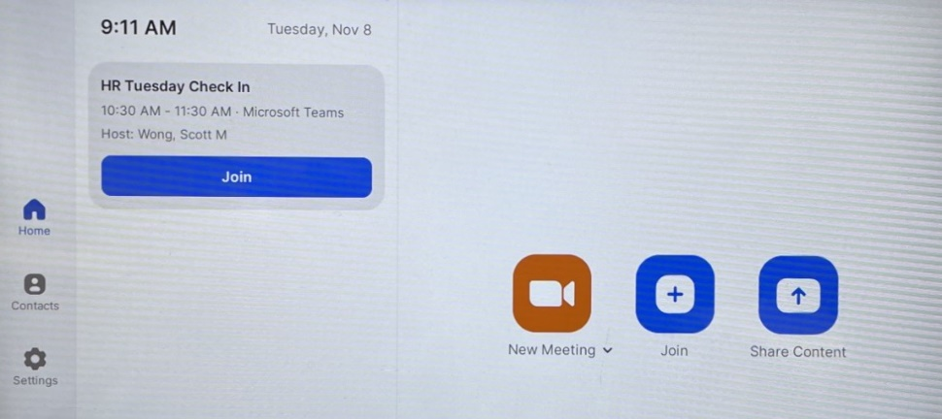
- Press the share icon on the Zoom Room Control Pod on the conference room table.

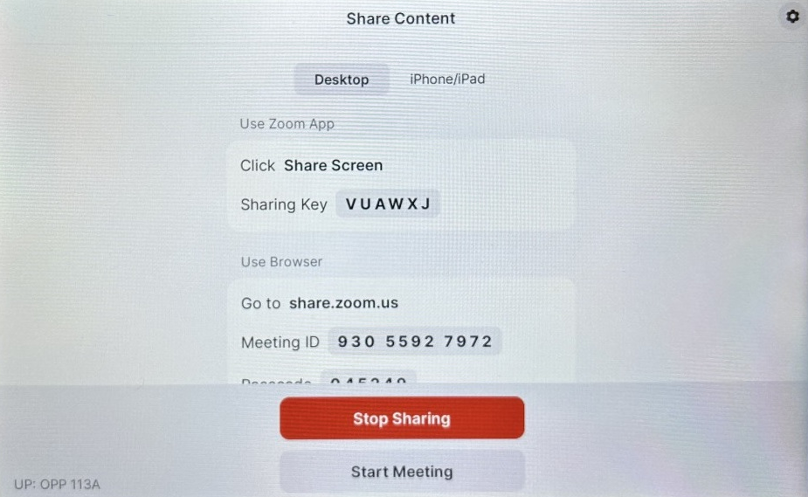
- Note the meeting ID displayed on the Control Pod.

- Enter the 11-digit meeting ID on the laptop screen and left-click “Share Screen” icon. (The meeting ID is displayed on the TV screen and on the Control Pod).

- Left-click on the “Open Link” icon that appears on the grayed out web browser screen.
- Enter the 6-digit meeting passcode on the laptop. (The meeting passcode is displayed on the TV screen and on the Control Pod). Left-click the “Join Meeting” icon.

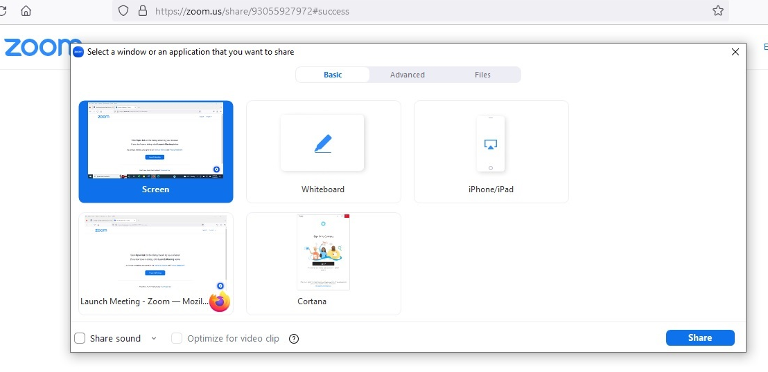
- Left-click on the laptop screen to be shared, then left-click on the “Share” icon in the lower righthand corner of the screen.
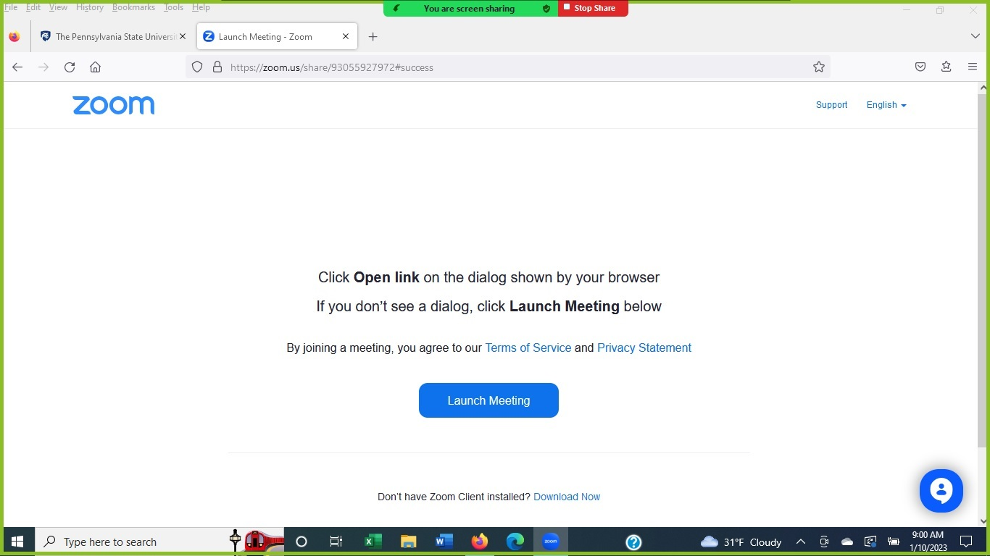
- The laptop screen is now outlined by a light green band to indicate that the screen is being displayed to the TV screens in the Zoom room. The green band can be “grabbed” and adjusted for size by using the laptop mouse to isolate content to be displayed. Just hover over the green band, then left-click on the band and hold as the mouse is moved to make the displayed area smaller or larger.

