Create and Print View By
Select Space Manager Module.
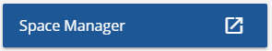
Search by Building name.
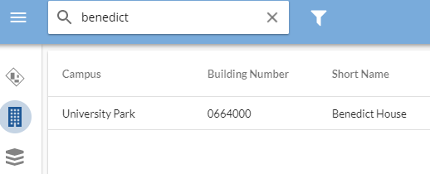
Select the ‘I” to view building foot print.
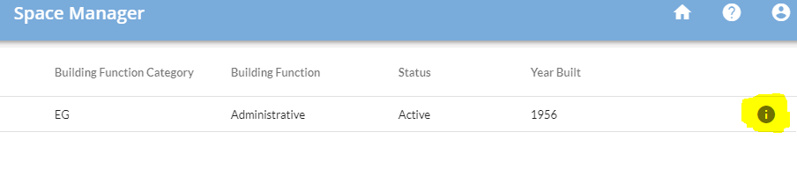
Select the desired floor level to create a view by (plan) for.
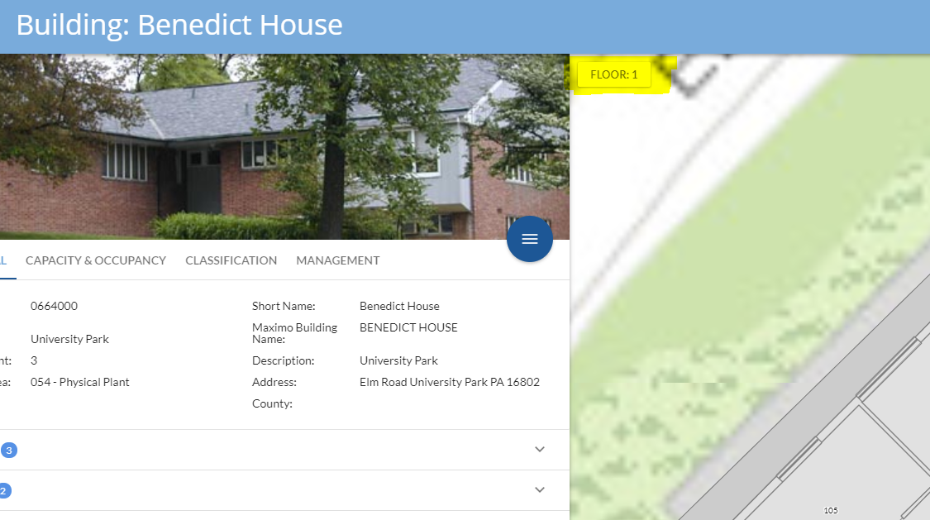

Select the “View Room By” box.
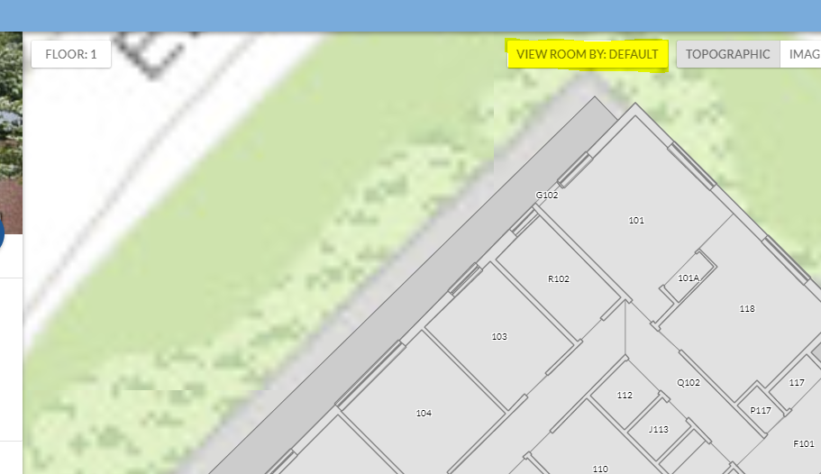
Select Create new view by.
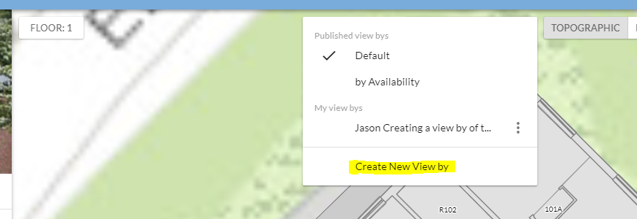
Type a meaningful name in the view by name box.
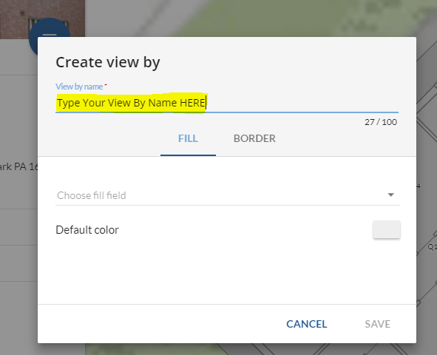
“Choose fill field”, by selecting the down triangle on the right.
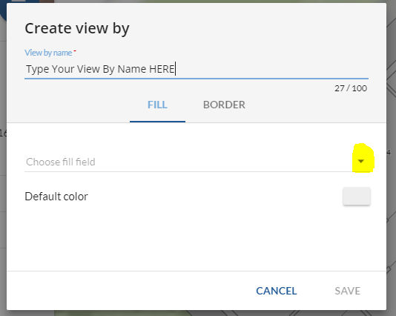
Select room Type (or one of the other options).
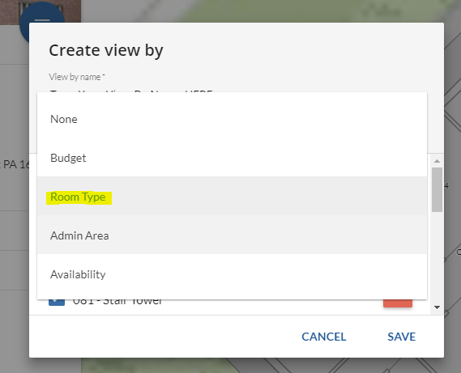

Select save.
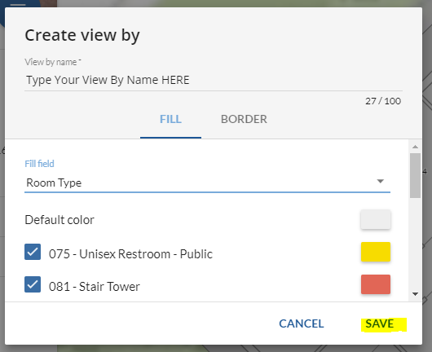
Map view should now be colored by your selection.
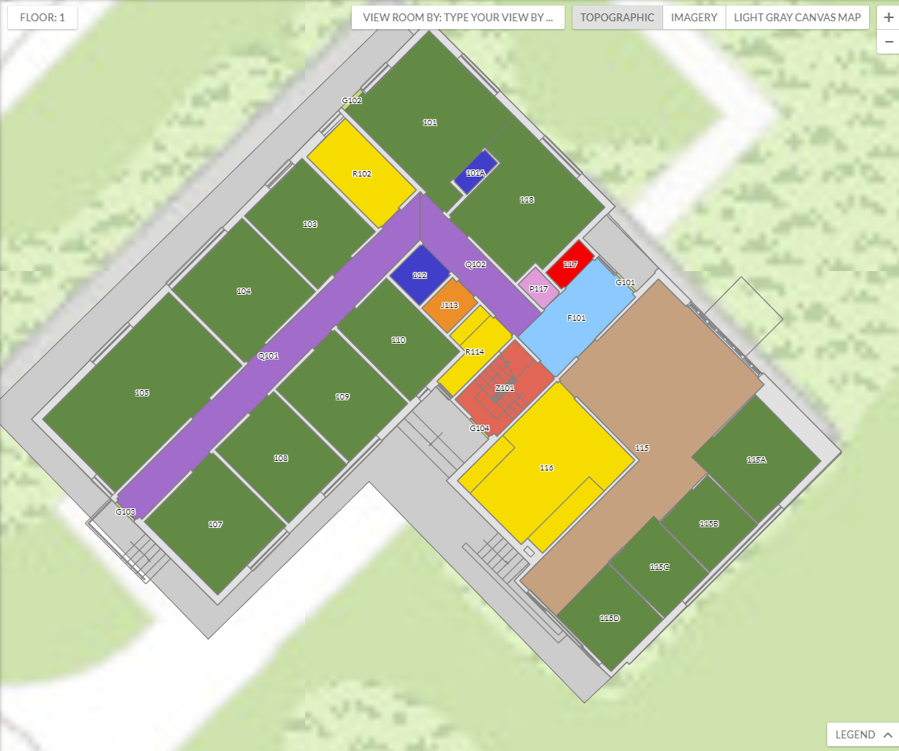
Click the legend button to the bottom right of the building footprint.
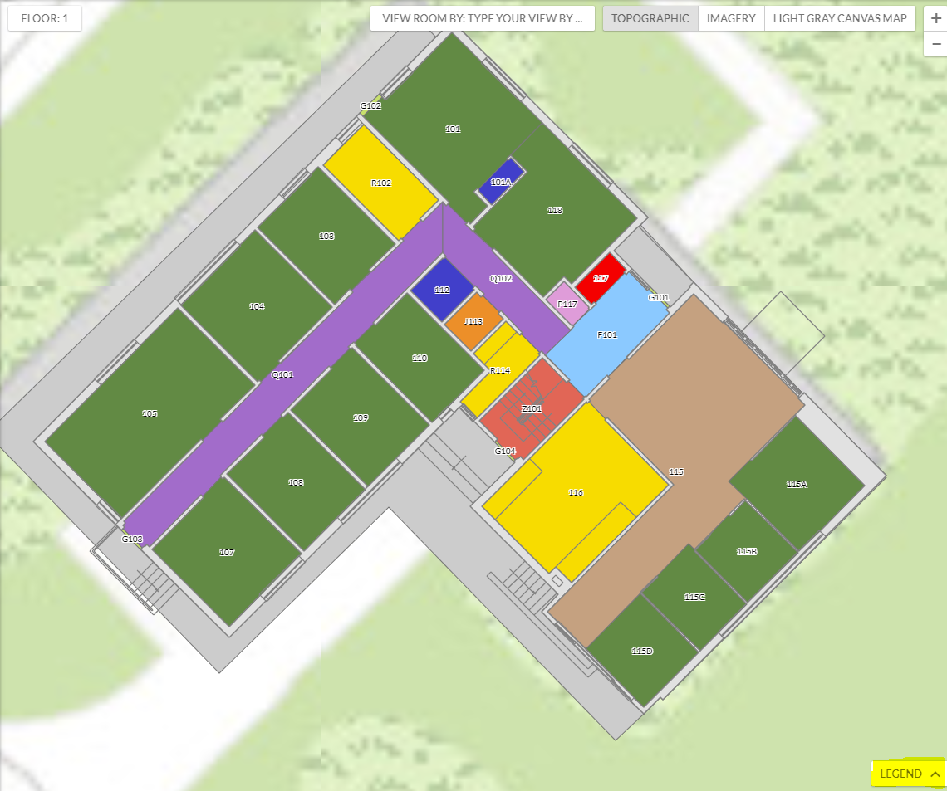
Click the hamburger menu by the image of the building.
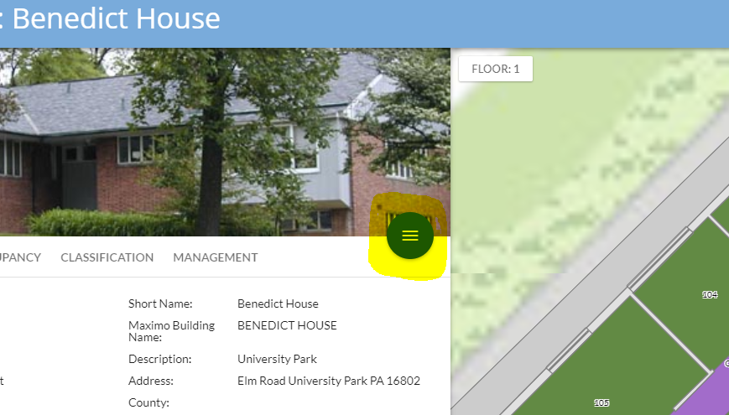
Click the printer icon.
Title your map.
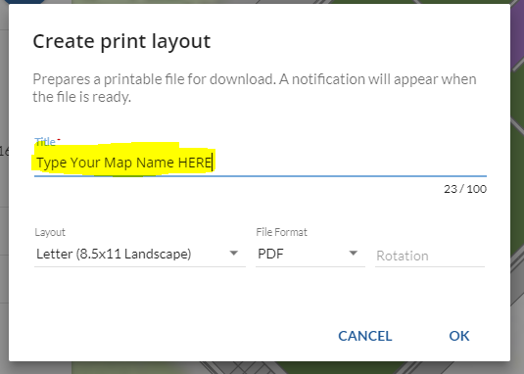
Select your layout size.
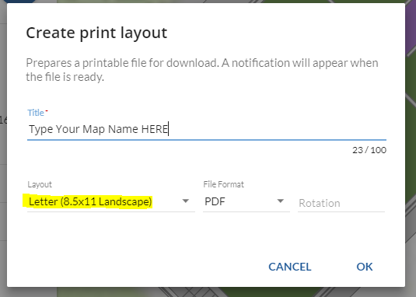

Select your file format.
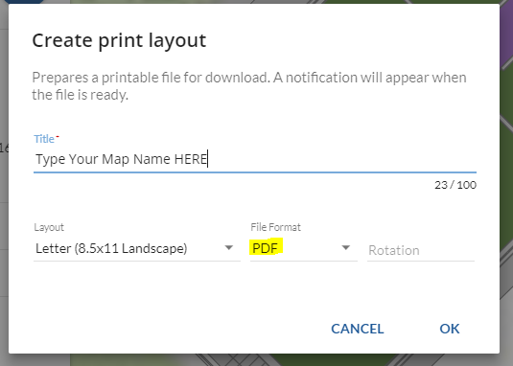
If you desire to view via “Penn State” North, use -45 in the rotation field.
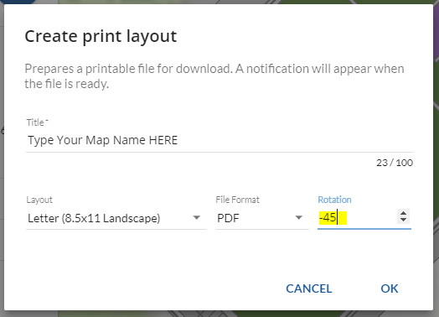

Select “OK”.
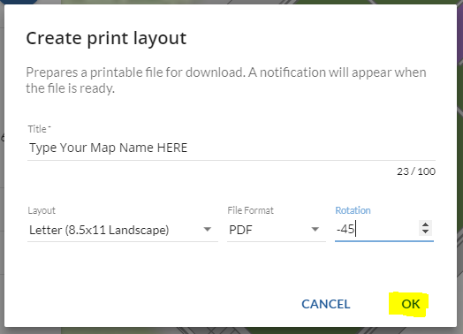
Download your map by Selecting download.
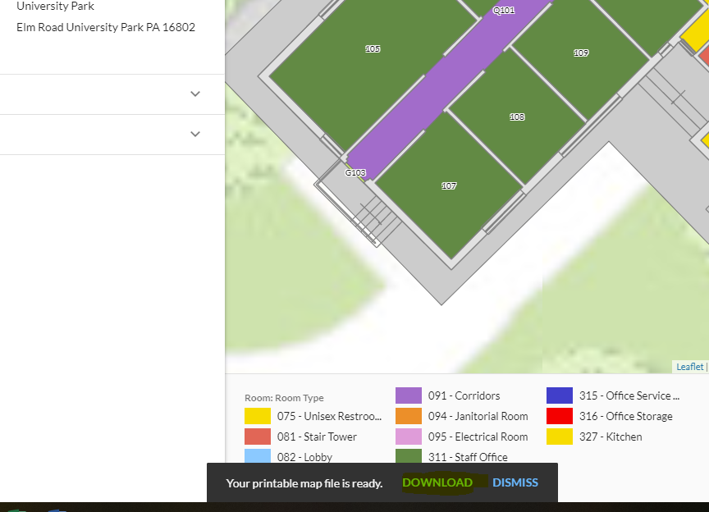

Print the PDF Version of your newly created Map by Room Type.
