Create and Campus Viewer floor plan.
Select Campus Viewer Module.
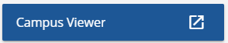
Filter by Building name.
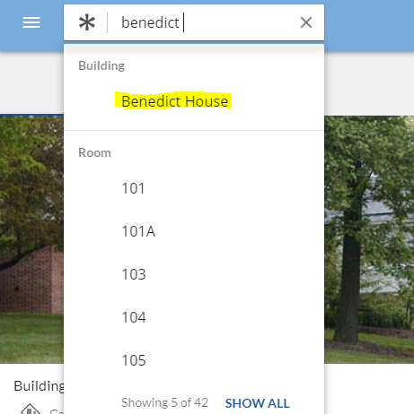
Select the floor using the floor selector in the upper left-hand corner of the map.
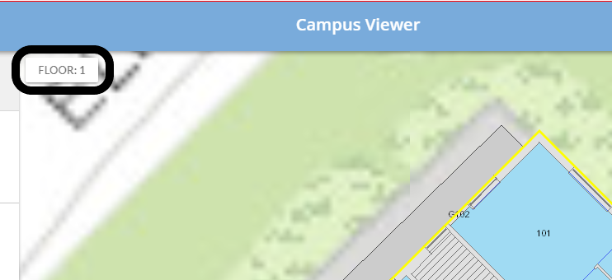
The desired floor level is now visible and be printed.
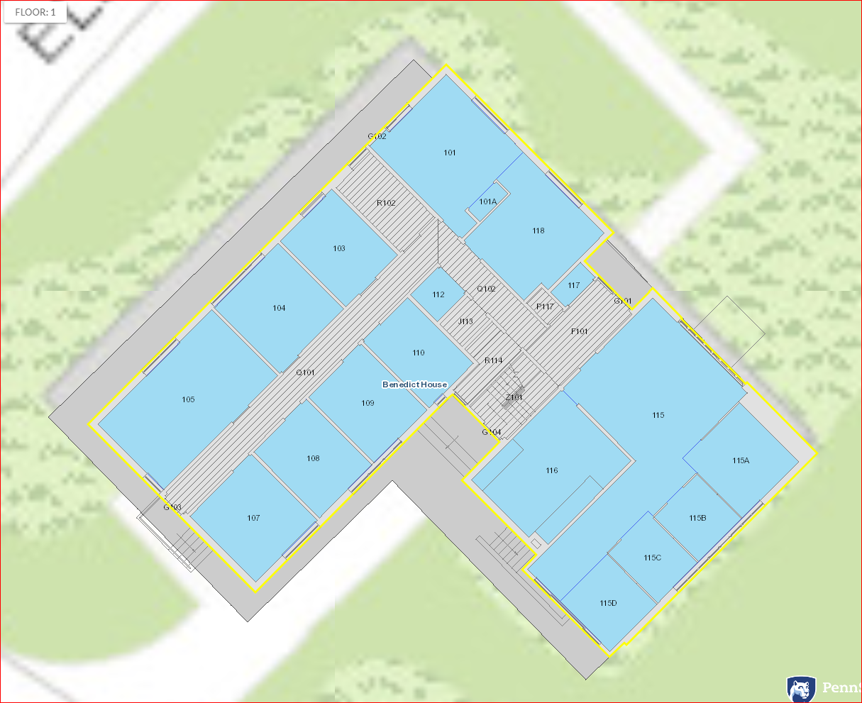
Select the options menu then the print Icon.
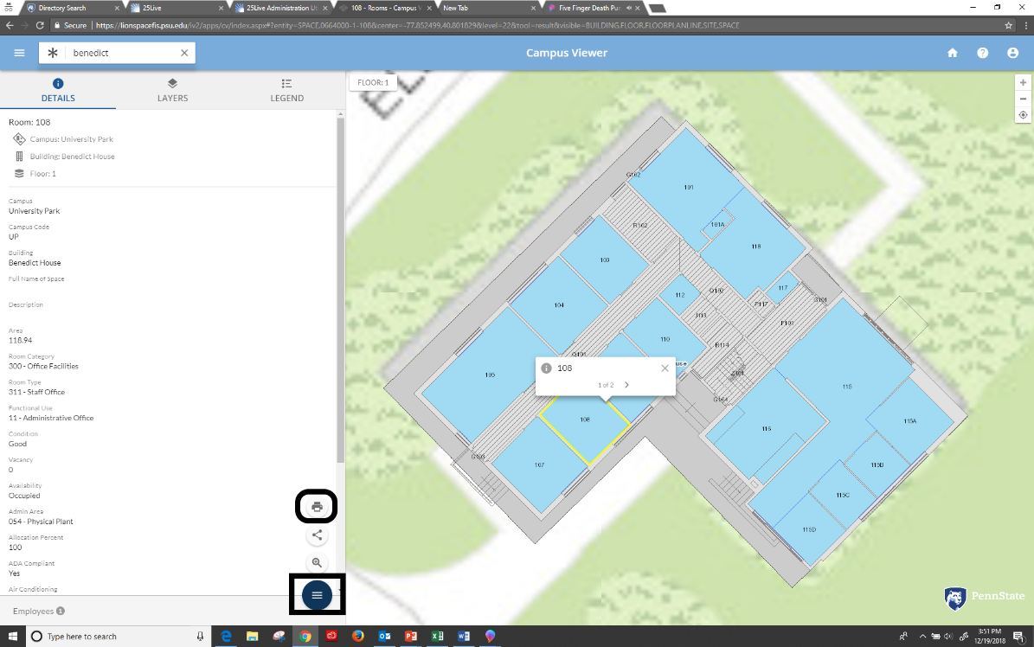
Title the floorplan:
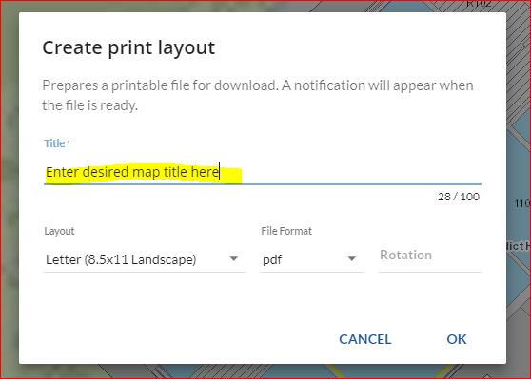
Select the desired Layout, file format and rotation, -45 rotation will get you close to “Penn State North” select ok.
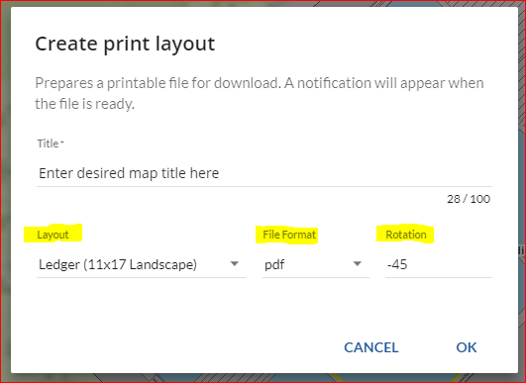
Download your map.
Share your map as desired.
